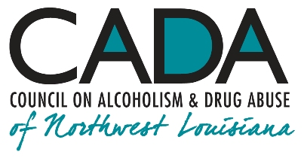
School of Addiction
and Behavioral Health

Educational Activity:
The Zombie Apocalypse Made Real: Methamphetamine Addiction

INTRO

Methamphetamine—or “meth,” as it’s commonly called—is a stimulant, one of a group of substances known collectively as amphetamines. Meth can be a white powder or a pill, and “crystal meth” looks like glass or shiny, bluish-white “rocks.” It’s taken into the body by snorting, smoking or by injection. It’s also known as crank, chalk, crystal, fire, meth, speed, and ice. Used properly, it has some legitimate medical uses. Used improperly, it can create a waking nightmare for addicts and for everyone who cares about them.

Hello, everyone, and welcome to our podcast! We’re coming to you from our studio at the Council on Alcoholism and Drug Abuse of Northwest Louisiana! I’m your host, Kent Dean, CADA’s Director of Clinical Development. Today, we’re discussing methamphetamine addiction; what it is and how it can be treated. You’ll be able to earn one contact hour of continuing education by completing the post-test after you listen to the program. We’ll give you instructions on how to do that at the end of the show.

Methamphetamine activates the central nervous system by causing dopaminergic (dopamine-making) and adrenergic (norepinephrine-making) cells to release extra amounts of those neurotransmitters into the space between cells (synapse) and also by blocking the retrieval back into the cell (reuptake) of dopamine and norepinephrine after they have been released.

Although methamphetamine has a couple of legitimate uses in medicine, for attention deficit disorder and, as something of a last resort, for appetite management, it does appear that many prescribers seem to be moving away its use.

Today, we’re going to be looking at the problem of meth abuse rather than at its legitimate therapeutic uses. So, how prevalent is meth abuse? According to the US Department of Health and Human Services, as of 2015, 4.5 million people aged 12 or older have used methamphetamine in their lifetime. 1.7 million people had used meth within the past year. 1.9 million people have injected meth.

1.

If we’re going to be discussing meth addiction, we have to gain some understanding of what addiction is in general. To understand addiction, we have to be familiar with the normal operation of the reward system in the brain. Under normal circumstances, when someone is hungry, for example, they will experience hunger pangs, and they’ll have a pleasurable anticipation of eating something tasty. In other words, they will crave food. Two primary areas in the middle of the brain make this happen: the ventral tegmental area (VTA) and the nucleus accumbens (NA), which together form what has often been called a “rheostat of reward.”
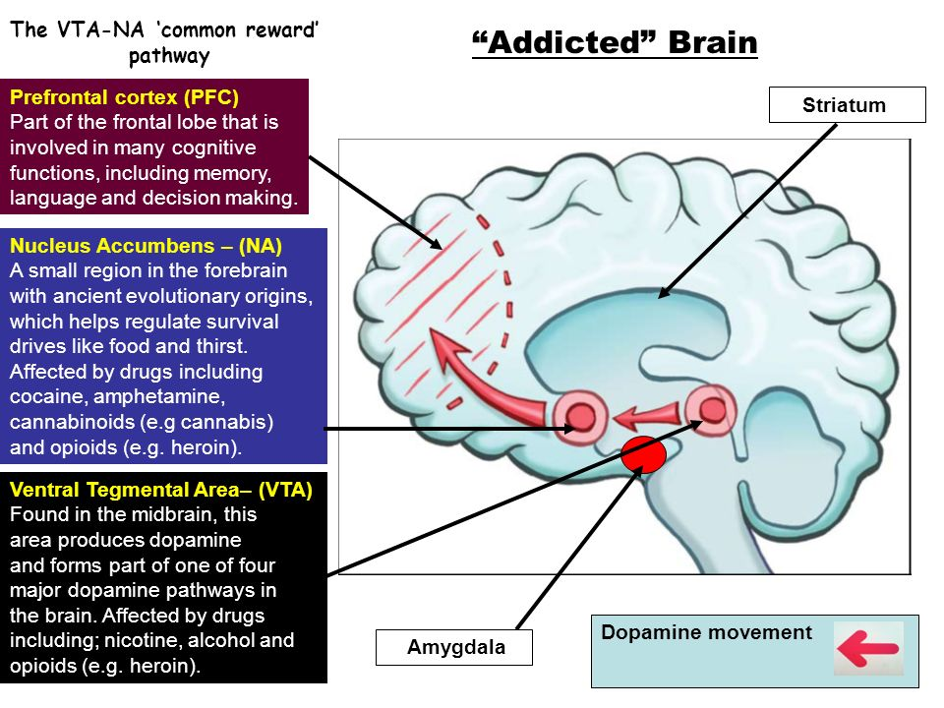

Tobias Walton

Both when the person anticipates eating and when they are enjoying a tasty meal, the VTA sends an electrochemical signal to the NA in the form of dopamine neurotransmitter molecules, sent from the VTA’s store of dopamine. The dopamine wends its way from cell to cell until it reaches the synapse bordering the NA neuron’s receptors. Once the dopamine reaches the NA, it activates that area, and, in return, the NA does two very important things: first, it responds back to the VTA by sending it a burst of a morphine-like substance known as enkephalin. This burst of enkephalin makes us feel good, just as would a hit of morphine. Second, the NA sends a burst of a chemical called serotonin to the prefrontal cortex of the brain, reinforcing a general good feeling and happiness. It’s clear that, when the pleasure system functions as it should, doing things that yield pleasure not only makes us feel good but also boosts our sense of well-being.

2.

People with normally-functioning pleasure centers can develop problems with addictive substances, but their difficulty probably won’t equal that of those who are predisposed to addictive disorders.

So what about people at risk to develop addiction? Addiction is an abnormal need, or craving, for certain substances or behaviors (such as gambling) brought about by progressive damage to the brain’s reward centers. For several reasons, including genetic factors, some people are born with a vulnerability to develop addiction if they do use or drink. Over time people can develop tolerance for certain chemicals, meaning they require more of the chemical over time to get the desired effect.

Tolerance, however, is not the only problem that develops. The neurons in the reward centers are “smart,” in that they gauge the degree of reward they receive when some activity takes place, a phenomenon that’s been called “reward prediction error.” When the next reward comes along, it is automatically compared with the reward already experienced, and if the new reward doesn’t provide a greater burst of pleasure, either by being more intense or by being unexpected, then the dopamine neurons don’t really fire much at that point. The reward is more or less ignored. (This is why repeating a pleasurable activity may be disappointing in many cases. It’s the “same ol’ same ‘ol.”) We should emphasize that this phenomenon, too, represents normal brain functioning, but its expression appears to be greatly amplified in its severity and effects in people with addiction.

Addicts can also experience withdrawal symptoms if the substance is taken away suddenly or if they can’t get enough fast enough to maintain intoxication. They then use as they do to try to satisfy the craving and to stay out of withdrawal.

Meth addiction has characteristic symptoms: The addict develops an ever-increasing need for meth to maintain the euphoria they feel when they first begin using it. Initially, meth users feel “high,” with a gloriously-expansive, even gleeful, outlook on life and on their ability to master life’s challenges. Self-esteem, energy and concentration spike at the beginning of an addict’s use. Some will say they’ve never felt so creative and in tune with the joy of life.

But … what goes up, comes back
down. Hard. Greater doses of meth
serve less and less well to provide the
spike in good feeling, and, before they
know it, addicts are using more but
getting less effect. It becomes more
difficult to “stay on an even keel,” and
this all happens before the person even
begins experiencing real withdrawal.
Loved ones will note a change of person-
ality in the user, who becomes preoccupied with using meth, getting over the effects of

3.

a using episode, and then preparing to find more meth. Someone once asked George
Carlin how using cocaine made him feel. He said, “It makes you feel like doing more cocaine.” The same thing can be said of meth. It is a major understatement to note that a meth addict’s life can become extraordinarily dysfunctional very quickly!

So what is it that makes meth so potentially addicting? In any human being, meth can overpower (“highjack”) the brain’s reward centers to such a degree that the initial good feeling, or euphoria, that it causes makes the person want to continue to use to get back that feeling. For those especially vulnerable to addiction, the brain adapts over
time, and maintaining euphoria quickly becomes an attempt to retain it. Retaining it soon becomes a futile effort to attain it at all. At that point, the addict can no longer achieve euphoria but merely succeeds in staying out of withdrawal. Over time, that capability also fades, and the addict can be left in a state of constant craving. As the saying goes, “One hit is too many, and a thousand are not enough.”

What do we see when someone had overdosed on meth? Euphoria followed by a rebound “crash” into depression, psychotic episodes, hallucinations, paranoia, violent rages, brain swelling, potentially fatal high blood pressure, abnormal heart rhythms, chest pain, shortness of breath, nausea, vomiting, and diarrhea. Meth can interfere with the body’s ability to maintain appropriate temperature, which can also be fatal. Lapsing into coma is a real possibility.

Meth is a stimulant, which means it overdrives, or overstimulates, brain cells that make dopamine, causing them to release too much of it into the space between cells. The dopamine-making brain cells would normally do their best to balance this excess by taking that extra dopamine back into themselves and storing it for use later. Since meth also prevents the cells from doing just that, an excess of dopamine rapidly builds up. One place dopamine is processed is in the reward centers of the brain. Dopamine buildup there causes powerful sensations of pleasure and euphoria. Other dopamine-processing parts of the brain regulate movement and concentration, and there, the buildup triggers increased alertness, energy and feelings of mastery in life. All this activity affects the front of the brain, too, where self-esteem and confidence take a very large—and very temporary—boost. The person thinks, “This is great! I’m feeling good emotionally, I having a lot of energy, and I’m able to concentrate effectively! I think I’ll keep on taking this stuff!” (So … what could possibly go wrong?)

4.

Coming down off of a meth high can be a steep step! Symptoms of withdrawal include depression and extreme irritability, confusion and memory difficulty. Energy peters out into fatigue. Heightened perception can spiral into a dim recollection of how it felt to be normal.

Meth use cause severe psychological problems. This is why prevention is key: You cannot overdrive the body for very long without sustaining some degree of permanent damage. If you spend a lot of time in very loud surroundings without hearing protection, you’ll lose some or all of your ability to hear. If you look at very bright objects, such as the recent solar eclipse, you can damage your eyesight or even go blind. If you overdrive the pleasure centers of your brain, you’ll cause them to become chronically fatigued, and you don’t have to be an addict to damage your brain. The reward centers become less attuned to the normal, everyday sensing of pleasurable activities, to the general ability to feel good. That lack of ability to feel pleasure also has effects in the front brain, and self-esteem and confidence suffer as well. Meth abuse over time causes depressed mood, confusion, emotional instability, even psychotic episodes.

The long-term effects of meth abuse are a waking nightmare and a walking death: depression, lethargy, inability to feel pleasure in much of anything (“I’ve stood on the moon; now I’m supposed to get all excited about standing at the top of Mt. Everest? Meh…”), malnutrition from appetite suppression, tremors very much like those seen in Parkinson’s disease, other movement problems, dental problems, arrhythmias, organ damage, confusion, irritability, despair, isolation, generalized fear, a sense of helplessness, pessimism, self-doubt, self-loathing. Long term abuse can cause “meth mouth,” in which the teeth and gums are damaged by the effects of the drug over time.

Some of the effects of meth on the brain may be long-lasting and even permanent. Recent research in humans has shown that, even three years after chronic meth users have stopped using, there is still a reduction in their brain cells’ ability to take dopamine back for storage and re-use later. This matters greatly because dopamine is involved with pleasure, mood, perception and movement; and, in its interaction with serotonin, it is also involved with self-esteem, confidence and belongingness.

Sounds like a pretty grim picture, doesn’t it? Well, it is. My bias has always leaned toward the belief that there’s no such thing as a good or bad prescription drug, just appropriate or inappropriate uses of therapeutic medications. Looking at the devastation that meth can cause does make me wonder if it might just qualify for “bad drug” status!

So, given all this bad news, is there any way we can help? Any way to treat meth addiction? Yes, indeed! Detoxification techniques are available to ease the transition from using to drug-free. Medications can be used to treat persisting symptoms, such as depressed mood and emotional instability. (Example: just as meth impairs the brain’s ability to conserve the transmitter supplies needed to remain stable, dopamine-evoking antidepressant medications actually help reverse that deficit to some extent by helping the brain more-effectively store up what transmitter it can now make.)

5.

Any therapy that helps the person with socialization and a sense of belonging has direct neurochemical benefits in the very same areas of the brain affected by addiction. Talking therapies have been found useful in helping recovering addicts reorient their self-image and stay abstinent from chemicals. Family networking therapy helps addicts “rejoin the human race” and take their place in their families and other relationships. Peer-support groups can be an important adjunct to treatment in providing a network of encouragement and shared progress in becoming and staying more stable.

Cognitive behavioral therapy (CBT) focuses on the development of personal coping strategies to solve current problems and change unhelpful patterns in thinking, behavior, and emotion. It was originally designed to treat depression and is now used for a number of mental health conditions, including addiction. It is based on the belief that symptoms and associated distress can be reduced by teaching new information-processing skills and coping mechanisms.

Contingency management helps addicts by providing positive consequences when they meet treatment goals and negative consequences when they don’t. An example of a positive consequence for abstinence could be receiving vouchers exchangeable for retail goods or progressing in a phased treatment program. A negative consequence could be withholding vouchers or a negative report to a parole officer. Therapists may create written behavioral contracts that detail the desired behavior change and other treatment details.

While they don’t cure it, there are medications, such as acamprosate, naltrexone, and some antidepressants, such as bupropion, that can stabilize the ongoing operating balance among the brain structures affected by addiction (specifically the ventral tegmental area, nucleus accumbens and frontal cortex). These medicines help do for the brain what it can’t do for itself; they are assistive technology for the brain.

So … Here’s the short version: Even though addiction—any addiction--can’t be cured, it can be stabilized, and it’s highly responsive to treatment!

OUTRO

That’s our podcast for today. If you’d like one hour of CE credit for just $5.00, you can go to the School’s website, cadaschool.com, click on “online courses,” and just follow the instructions. Once you pass the post-test, which includes evaluation questions, you’ll be able to download and print your certificate of completion. Be sure and stay in touch on Facebook! See you next time!

6.

