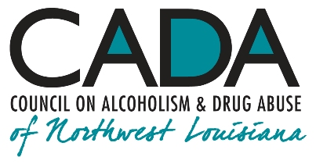
School of Addiction
and Behavioral Health

Educational Activity:
“Getting Old Ain’t for Sissies!”
Seniors and Addiction

INTRO

The great Bette Davis once said, “Getting old ain’t for sissies!” Vicissitudes of aging lend themselves to temptations to medicate away loneliness, anxiety and pain by various means. Someone who’s been uprooted, newly widowed, or geographically displaced may well look to some chemical to feel better—or to not feel at all.

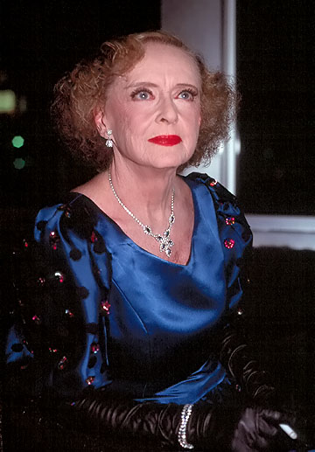

Hello, everyone, and welcome to our podcast! We’re coming to you from our studio at the Council on Alcoholism and Drug Abuse of Northwest Louisiana! I’m your host, Kent Dean, CADA’s Director of Clinical Development. Today, we’ll discuss doing the seemingly-impossible in achieving and maintaining an abstinent recovery in addiction. Is it really possible? You’ll be able to earn one contact hour of continuing education by completing the post-test after you listen to the program. We’ll give you instructions on how to do that at the end of the show.

The growing population of older people, including yours truly, the so-called “Baby Boomers,” born between 1946 and 1964, has long been exposed to various ways of feeling good; “If it feels good, do it” was a common watchword for this generation. Unfortunately, as often as not, something that feels good can bring not only a sense of euphoria, relaxation and forgetfulness but also impairments in physical and emotional functioning and further isolation and despair.

1.

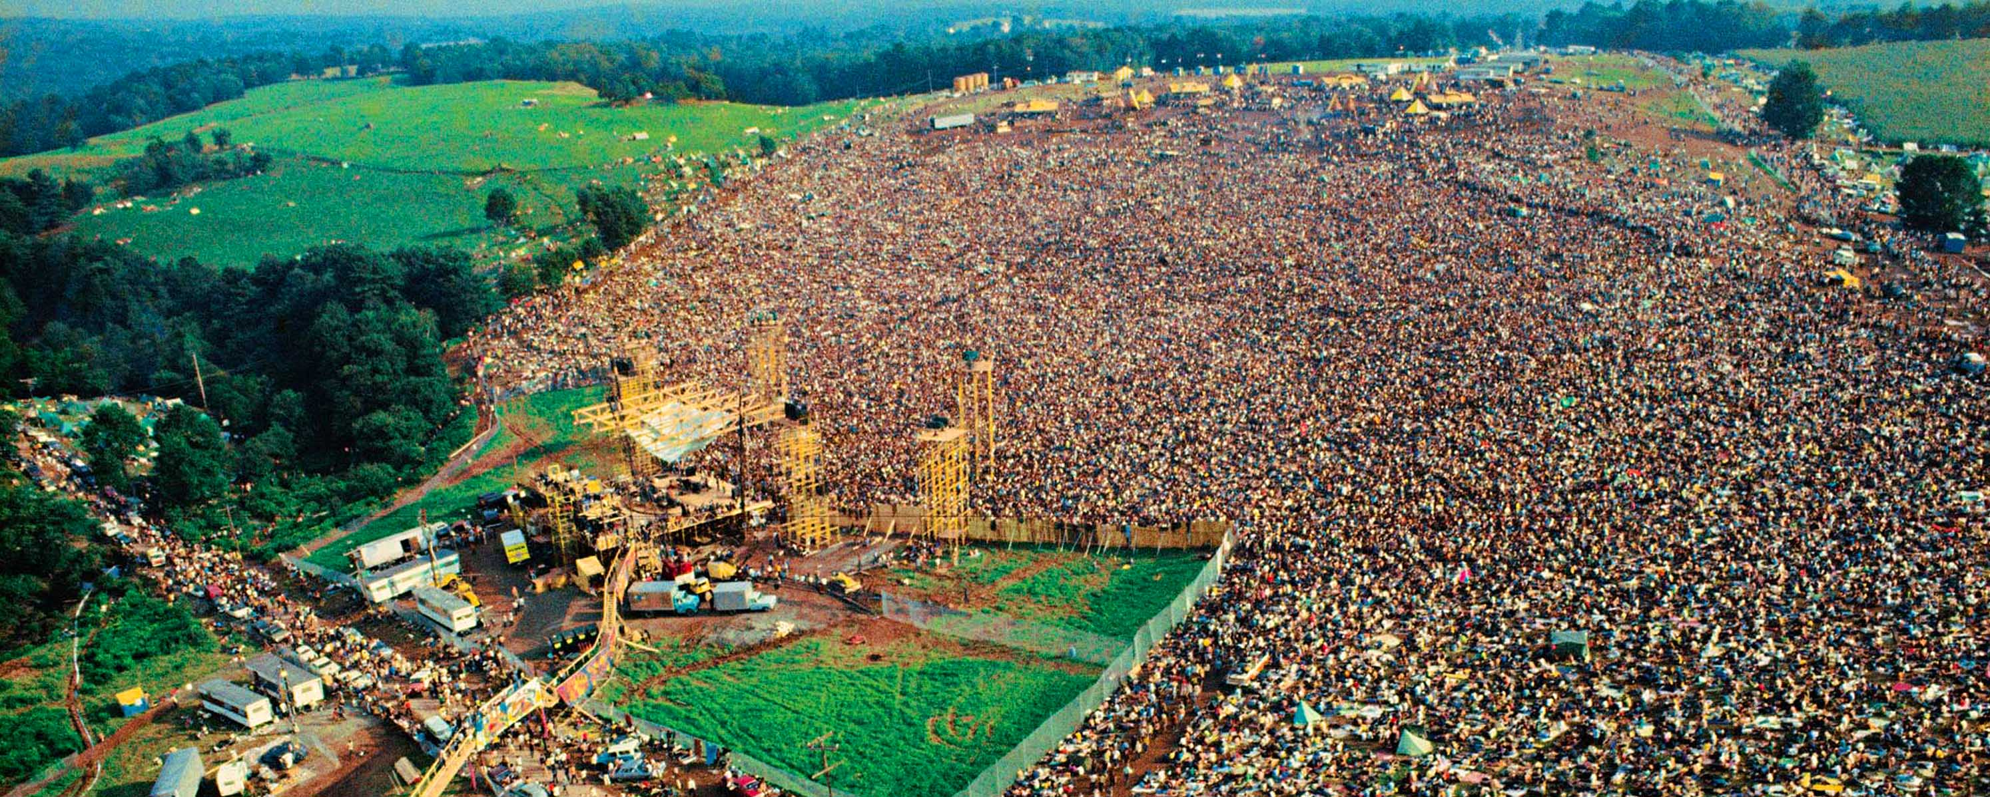

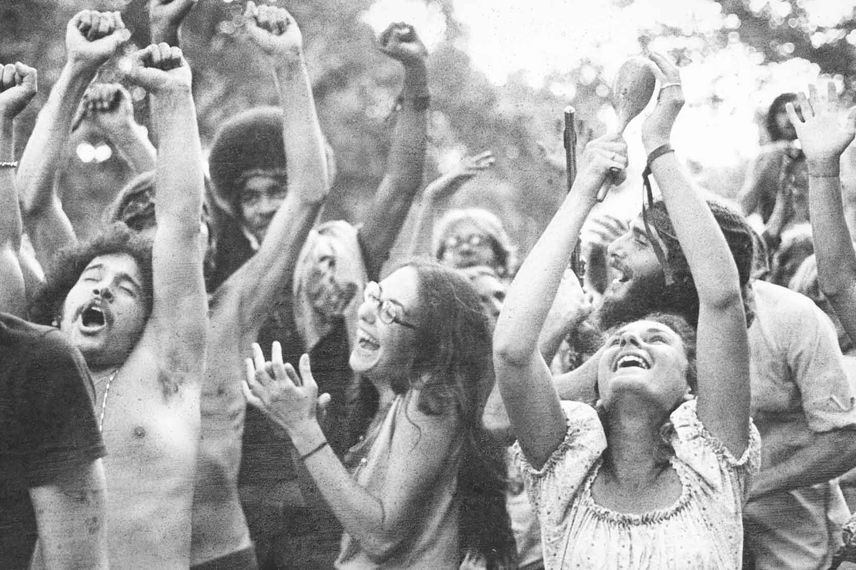
The iconic Woodstock Music & Art Fair held in the Catskills in 1969 was seen at the time as a culmination of the ethic of “letting it all hang out.” Youth—yes, we, too, were young once—who flocked to the area were immersed in the heady atmosphere of hearing good music, feeling “good vibes,” and using prodigious amounts of alcohol, marijuana, LSD, and other drugs. Many of the would-be “hippies” gathered there saw themselves as the vanguard of a new way of living, liberated from past conventions, heralding an “Age of Aquarius,” an era of pacifism and good feeling, in a vivid contrast to what had become the widely unpopular war in Vietnam and in pointed reaction to the assassinations the previous year of Robert Kennedy and Martin Luther King, Jr.

The festival was the subject of an Oscar-winning documentary, a narrative of the sights and sounds of those four days. In the film, the initial merriment and camaraderie give way subsequently to more-somber and occasionally tragic scenes as inclement weather, inadequate food, poor sanitation and excessive use of chemicals take their toll on the overflow crowd. By the end of the film, we see that many drug overdoses (and a couple of deaths) have dampened the initial optimism of more than a few of the festivalgoers, exposing euphoria’s rebound, fatigue and depression.
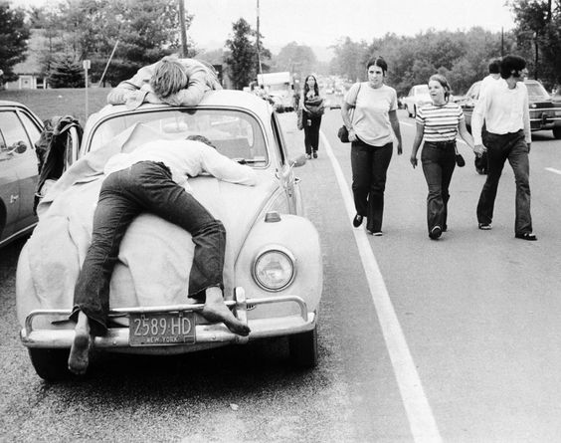

2.
As the youth of the “Woodstock Generation” resumed their daily lives, three outcomes showed themselves. One group developed noticeable drug dependence, a minority achieving recovery in addiction, with the other unfortunates not infrequently dying young. Another group seemingly “got it out of their system,” ultimately remaining free of further consequences. The third group went about their lives, laying aside—for a time—excessive use of alcohol or other drugs. What was poorly understood at the time was that the genetically-vulnerable young people who had been exposed (or re-exposed) to mood-altering chemicals had primed their brains to set in place a downward spiral of addiction.

The second and third groups made a life for themselves, finishing college, establishing careers, and starting families. Socialization was an important aspect of life to this generation, and—legal or not—the allure of chemicals in addition to alcohol was compelling enough that many used marijuana and cocaine “recreationally.” At the time, the prevailing belief seems to have been that such episodic use wasn’t doing them or anyone else any harm. After all, they’d gotten this far with no adverse effects from earlier drug use, hadn’t they?

The years went by, and, as they say, “Life happened.” One group went on to establish and expand their careers and moved nearer to retirement age. As they entered and then passed late middle age, some found their life circumstances changing in a host of unwelcome ways: Children and grandchildren moved away. Marriages dissolved. Beloved spouses died. Employment crises ensued. Painful and debilitating physical and mental conditions appeared or worsened. Old friends relocated or died.

A life filled with family, friends, independence, and prosperity was sometimes replaced with isolation, a growing dependence on caregivers, financial challenges, and feelings of grief and loneliness. For many, the life review accompanying having lived a long time disclosed a “glass half empty” verdict. For many seniors, the combination of these circumstances set the stage for a potentially disastrous—and, as-yet-unheralded—“perfect storm,” leaving them bereft of emotional and physical well-being.

3.

Re-enter a new-old friend: alcohol or some other mood-altering drug. After a few moments, painful emotions and memories recede. That nostalgic ache no longer gnaws at the mind. Long-dismissed memories of youthful substance use and euphoria come flooding back. Aches and pains diminish. A sense of repose and calm dawns. Optimism replaces disappointment. What’s more, it takes less of the substance to bring about these good feelings. “If it feels good, do it.” What could possibly go wrong?

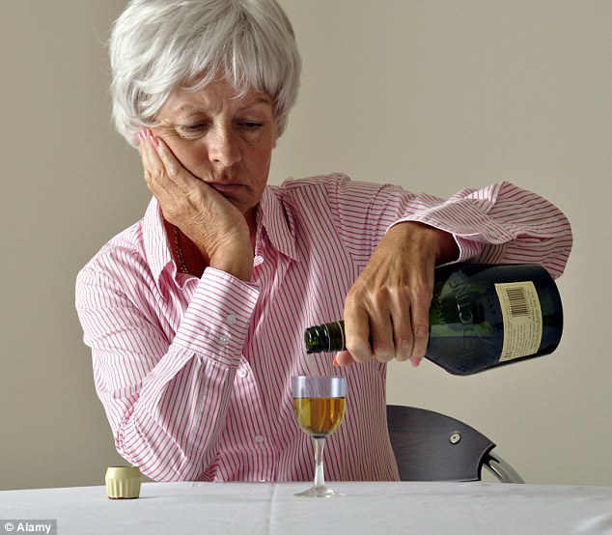
The answers to that question are self-evident to those of us observing the chemical cocoon in which the person enfolds themselves. Combine the problems of addiction with the effects of not taking positive action to adapt and re-fashion one’s life when major changes occur, and you have a recipe for suicidal despair.

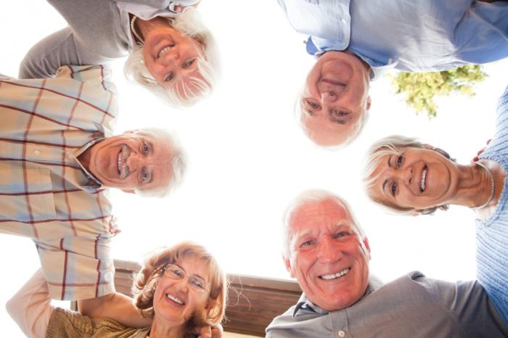

All isn’t lost, however. Aging issues demand collaboration with gently-assertive and supportive caregivers: old and new friends, extended family, various peer supports, and counselors and medical providers who specialize in helping older people. Receiving and reciprocating the right kinds of advocacy can make the difference between a life fading out in self-imposed exile and a narrative better than any film, one that imbues seniors with comfort and purpose, inspiring and empowering everyone around them.

OUTRO

That’s our podcast for today. If you’d like one hour of CE credit for just $5.00, you can go to the School’s website, cadaschool.com, click on “online courses,” and just follow the instructions. Once you pass the post-test, which includes evaluation questions, you’ll be able to download and print your certificate of completion. Be sure and stay in touch on Facebook! See you next time!

4.

