School of Addiction
and Behavioral Health

Educational Activity: “We’re All the Same!”
Ethics and Etiquette in Treating
People with Disabilities

INTRO

We all probably know at least one person with a disability. Their disability might be an obvious one, like the inability to walk, or it might be less noticeable, such as a developmental disorder. Whatever the specific issue, the majority of people with disabilities have the normal goals and aspirations, and they’re quite capable of leading productive lives. They clearly need neither pity nor over-attentiveness. You don’t have to feel awkward when interacting with a person with a disability. If you're ever unsure about what to do or say, just ask! As a colleague of mine is fond of asserting about human beings, whether disabled or not, “We’re all the same!”

Hello, everyone, and welcome to our podcast! We’re coming to you from our studio at the Council on Alcoholism and Drug Abuse of Northwest Louisiana! I’m your host, Kent Dean, CADA’s Director of Clinical Development. Today, we’re discussing the art and etiquette of professional interaction with people with various disabilities. You’ll be able to earn one contact hour of continuing education by completing the post-test after you listen to the program. We’ll give you instructions on how to do that at the end of the show.

So, what is the best way to interact with a person with a disability? The answers are disarmingly obvious and simple. Here are some basics:
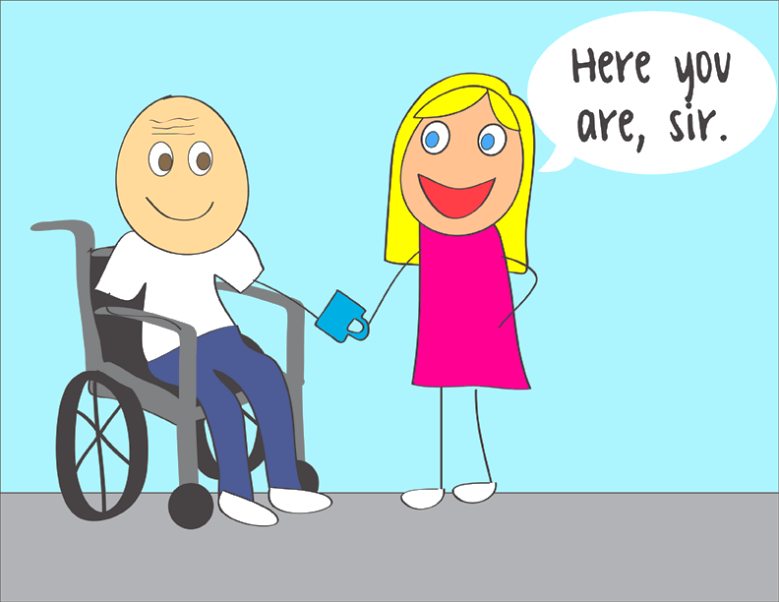

1.

1. Ask Before You Help

Don’t assume someone with a disability needs help. If the setting is accessible, they can usually get around fine. Adults with disabilities want to be treated as independent people. Offer assistance only if the person appears to need it, and if they do want help, ask how best to help before you act.

2. Be Sensitive About Physical Contact

Some people with disabilities depend on their arms for balance. Grabbing them – even if your intention is to assist – could knock them off balance. Because people with disabilities consider their equipment part of their personal space, you should avoid patting them on the head or touching their wheelchair, scooter or cane.

3. Think Before You Speak

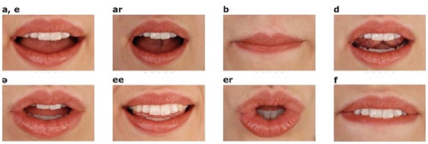
Always speak directly to a person with a disability, not to his companion, aide, or sign language interpreter. Make small talk if you want, as you would with anyone else. Respect their privacy. If you ask about their disability, they may feel like you are treating them as a disability, not as a human being. (That being said, it’s also true that many people with disabilities are comfortable with questions.)

4. Respond Graciously to Requests

When people who have a disability ask for an accommodation at your business, it's not a complaint. It shows they feel comfortable enough in your establishment to ask for what they need, and if they get a positive response, they'll probably come back again and tell their friends about the good service they received.

5. Avoid Making Assumptions

People with disabilities are the best judge of what they can or can’t do. Don’t make decisions for them about any activity.

Now that we have the basics down, let’s apply the “Golden Rule” and see how that informs our descriptions of someone with a disability.
2.

1. Consider saying “persons with a disability” rather than “disabled person” or “people
with disabilities” rather than “the disabled.” Rather than referring to someone as a
“spinal cord injury,” for example, say “person with a spinal cord injury.”

2. “Handicapped” or “crippled” are outdated terms. Be aware that many people with
disabilities dislike euphemisms such as “physically challenged.”

3. “Wheelchair user” is more accurate than “confined to a wheelchair” or “wheelchair
bound.” The wheelchair is what enables the person to get around and participate in
society; it's not confining; it’s liberating.
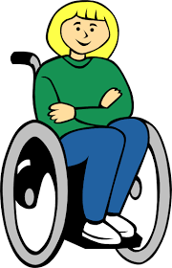
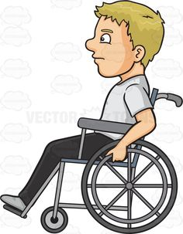

4. It’s appropriate to use common, colloquial expressions when talking to people
with disabilities, such as “see you later” with someone who’s blind.

5. When referring to any person with a disability, avoid negative words like “victim” or
“sufferer;” for example, avoid expressions such as “He’s a stroke victim." or "He
suffers from a traumatic brain injury.”

6. People with disabilities are individuals. They’re your friends, co-workers and
neighbors. Remember: Ask and listen! People with a disability are the experts about
their disability. Just remember, as people, basically: "We’re all the same!”

Now, let’s zero in on some specifics of etiquette for those with specific disabilities.

People Who Use Wheelchairs

1. Always ask the person using the wheelchair if he or she would like assistance before
you help.

2. No one likes someone hovering over us while we’re talking to them, so if the
conversation lasts more than a few minutes, sit or kneel to get to eye level.

3. Address all people with disabilities directly; don't speak to them through others who
may be with them, as though they don’t exist.

4. Don’t hang on to, hold, or lean on a person’s wheelchair. It's part of the wheelchair
user’s personal body space, just as a pair of glasses or hearing aids would be.

5. When a wheelchair user transfers out of the wheelchair, don't move the
wheelchair out of reaching distance.

3.

6. Don’t classify people who use wheelchairs as “sick.” After all, wheelchairs are used
for a variety of disabilities.

7. Since a wheelchair provides freedom and allows the user to move about
independently, don’t assume that a person's use of a wheelchair is in itself a
tragedy.

8. If the person appears to have little grasping ability, don't be afraid to try to
shake hands. A handshake is traditional, and it signals that you're giving equal
consideration. It's important to allow the person to guide you. He or she will have
developed ways to handle almost all common social situations.

9. Avoid disempowering terms like "cripple," "confined to a wheelchair," "wheelchair
bound," "deformed," "cord," "para" or "quad." Use terms such as "person with a spinal
cord injury" or "wheelchair user."

People Who Are Blind or Visually Impaired

1. Ask the person if he or she wants help in getting about. When providing
assistance, don’t grab and start steering. Allow the person to take your arm, bent
at the elbow. If you encounter steps, curbs or other obstacles, identify them.

2. Always identify yourself before you make physical contact with people who are blind.
Tell them your name and your role, if appropriate, such as receptionist. Identify any
others who may be with you; say, for example, “On my right is...” Use their name
when starting a conversation to let them know where the conversation is directed.
Let them know when you need to leave the conversation.

3. To handle money or other papers, identify each piece while placing it in the person’s
hand.

4. When you help them sit down, guide their hand to the back of the chair, and tell them
whether the chair has arms.

5. Be as clear and specific as possible when giving directions. Estimate the
distance in steps, and point out obvious obstacles in the direct path of travel.

4.

6. Speak directly to the person in a normal tone and speed. Don't shout or speak in a
loud voice.

7. When someone with a visual impairment must meet many people, introduce
them individually, and encourage everyone introduced to speak. This process
helps people who are blind more-reliably associate names and voices for subsequent
encounters.

8. Resist the temptation to pet or play with a working guide dog. Remember that the dog
is on duty and shouldn’t be distracted. If the person has a guide dog, walk on the side
opposite the dog.

9. If someone uses a cane, avoid touching it, since it’s part of their personal space. If
they put the cane down, don’t move it. Let them know if it's in the way.

People Who Are Deaf or Hearing Impaired

1. If necessary, get the person’s attention with a wave of the hand or light tap on the
shoulder.

2. Don’t be embarrassed about communicating with paper and pencil.

3. Speak clearly and slowly but without exaggerating. Don’t shout. Use body language,
facial expression or pantomime to help; on the other hand, don’t “overact” and
exaggerate your communication. Use a normal voice tone, and always provide a
clear view of your mouth.

4. Avoid standing in front of a window or other light source, which might silhouette your
face, making it difficult to see; conversely, in a very dark room, communication will
also be problematic.

5. Try to maintain eye contact. Since they may be lip reading, allow for a clear view of
your face. Don’t speak directly into their ear.

6. Explain any interruptions, such as a phone ringing or a knock at the door, before
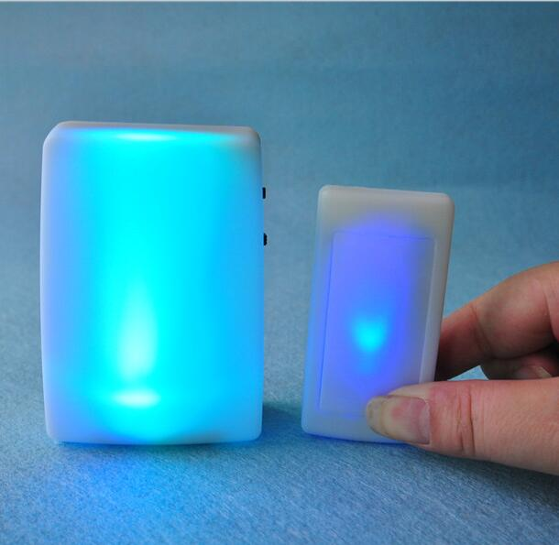
attending to it.

Lighted doorbell

7. If the person is using an interpreter, speak directly to the person with deafness – not
to the interpreter.

5.

8. Avoid stereotyping, offensive terms such as "deaf and dumb," "deaf mute," or "the
deaf." Use "persons with deafness," "people who are deaf," or "persons with a
hearing loss."

9. While they improve hearing and understanding, hearing aids do not restore normal
hearing. Remember that people who wear them are affected by sudden, loud
noises or shouting. Sudden loud sounds can be very startling or even painful.

People Who Have Speech Difficulties

1. Give whole, unhurried attention to the person.

2. Keep your manner encouraging, rather than correcting. Don’t tease or laugh at a
person with a speech disability.

3. Rather than speak for someone, allow extra time and give help when needed.
Don’t finish their sentences.

4. When necessary, ask questions that require short answers or a nod or shake of the
head.

5. Don’t pretend to understand when you don’t. Repeat what you do understand; the
person’s reaction will clue you in and guide you.

6. Look for communication aids like pictures or symbols that might help.

People with Mental Disorders, Including Addictive Disorders

1. Be aware that the person may be in early recovery and may be susceptible to being
triggered by explicit conversations about drinking or gambling, etc.

2. If the person shows reluctance to go to a specific restaurant with a bar or to a
casino, honor their reluctance and never press them to go anyway. There are
almost always other options for entertainment or eating out.

6.

3. People who are compulsive eaters in recovery will be aware of the restrictions they
have decided to place on their diet. It is never a good idea to press them to eat a
specific food (including dessert).

4. Holidays can be especially challenging for people with addictive or mood or
anxiety disorders. In recovery they practice strategies to cope effectively, but
being supporting and understanding can emphatically help them stay stable.

5. Don’t classify people who have addictive disorders or other mental disorders with
some pejorative term like "drunk," "junkie," or "crazy,” since mental illness isn’t
something people bring on themselves, but a biological problem responsive to
proper treatment and good patient compliance.

6. Remember that medication for management of mental illness (including
addictive disorders) is the rule rather than the exception. People who use
medication must never be pressed to stop by non-physicians. Doing so is practicing
medicine without a license, which is both illegal and potentially life threatening.
Psychiatric medications are assistive technology just as are wheelchairs, canes or
contact lenses, and they’ve been adjusted to be an integral part of the person's
functioning with the same sort of precision as any other assistive technology.
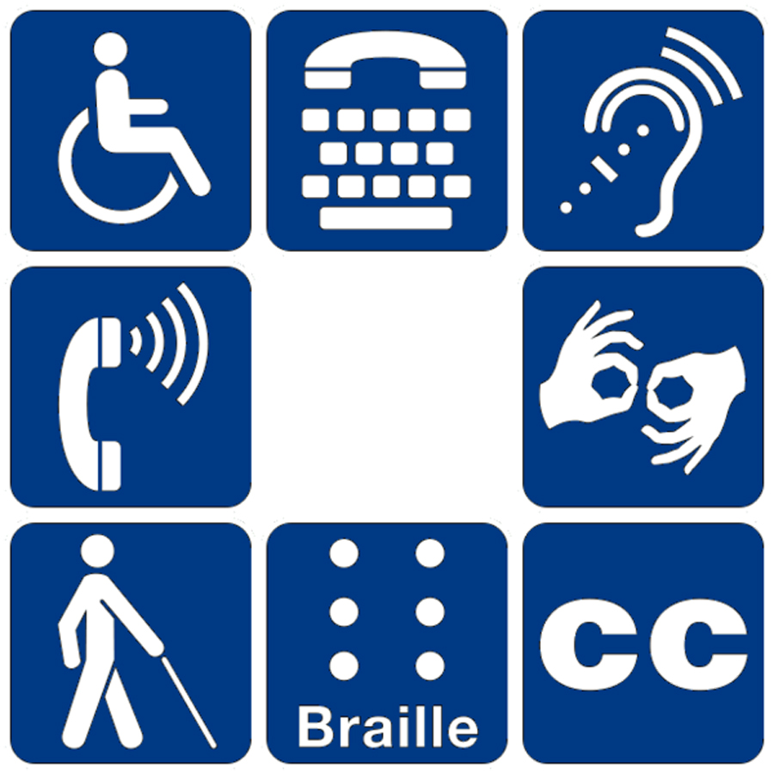

OUTRO

That’s our podcast for today. If you’d like one hour of CE credit for just $5.00, you can go to the School’s website, cadaschool.com, click on “online courses,” and just follow the instructions. Once you pass the post-test, which includes evaluation questions, you’ll be able to download and print your certificate of completion. Be sure and stay in touch on Facebook! See you next time!

7.

