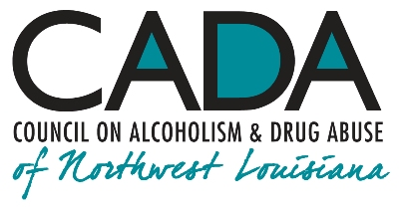
School of Addiction

and Behavioral Health

Educational Activity:

Addictive Disorder, Major Depressive Disorder and Attention- Deficit/Hyperactivity Disorder: A “Trifecta” of Trouble

INTRO

Just imagine everyday life for someone struggling with an addictive disorder who also finds themselves burdened simultaneously with the disruptions caused by major depressive disorder! Addiction and depression are major mental illnesses, each alone presenting daunting challenges in navigating daily living. Adding attention deficit disorder to the mix creates a “Trifecta” of Trouble—to borrow a parimutuel betting term.

Hello, everyone, and welcome to our podcast! We’re coming to you from our studio at the Council on Alcoholism and Drug Abuse of Northwest Louisiana! I’m your host, Kent Dean, CADA’s Director of Clinical Development. Today, we’re discussing the triple threat of addictive disorders copresenting with attention-deficit disorder and major depressive disorder. You’ll be able to earn one contact hour of continuing education by completing the post-test after you listen to the program. We’ll give you instructions on how to do that at the end of the show.

You know, it’s small wonder that people turn to self‐sedation through drugs or gambling to cope with this whirlwind of confusion and strife! If this scenario seems fanciful, just remember that the majority of people with an addiction do, likely, suffer simultaneously with one or, frequently, both of these illnesses to one degree or another. Addiction treatment demands that any and all these disorders (and more) be treated effectively and at the same time. Doing so isn’t only humane, but effective relapse prevention is nearly impossible without doing so.

1.

Neurobiology of Inhibition

In recent years, a quiet revolution in treating addictive and other psychiatric disorders has taken place. Cognitive-behavioral therapy, didactic therapy (patient education), peer-support groups (including 12-Step groups such as AA, NA, GA, etc.), and other modalities all prove helpful to those seeking recovery. Nonetheless, they fail to address consistently a major impairment that people with addictive disorders, people with depression and people with ADD bring to stable abstinence: the abilities to pre-envision, order and carry out tasks artfully.

It is becoming clearer that sustained success in abstinence and recovery involves learning and practicing remedial facility in ordering behavior: sustaining attention, self-pacing repetitive and sequential behavior, placing a delay on reaction, and declining to react.
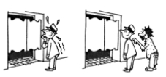

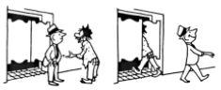

In the cartoon, “Victor E”. is “sweating out” a desire to go into the bar and take a drink. Although we have a right to ask him why he’s standing outside the bar to begin with, we note that his being interrupted by a fellow alcoholic, who’s not yet in recovery, does serve to distract Victor from his obsession and gives him some time to use his reasoning ability and then get himself out of the area.
Jack M.: “Victor E.’ (March 1962)

Copyright © 1962 AA Grapevine

Research consensus describes addiction as a chronic neurological disorder, which both involves and worsens specific deficits, including problems in cognition, motivation, and insight; behavioral disinhibition; attention deficits; emotional

2.
instability; impulsiveness; aggressiveness; depression; anhedonia; and persistent movement disorders. Exercises (“games”) are available that enhance the function of specific areas of the brain typically under-practiced in active addiction and in early recovery.

It has been demonstrated repeatedly that specific areas of the brain respond to various types of practice. As these areas become more adept at the skill they are being taught, the skill sets become more automatic.

Harm reduction strategies stem from the desirability of adopting and sustaining practices that mitigate risk and minimize the frequency and severity of harm to our patients (as in a relapse). As important as theory (didactic therapy) is in psychiatric disease management, its utility is realized only in the doing of behaviors that promote abstinence and recovery. (An early illustration of this truth is found in the Twelve Steps of Alcoholics Anonymous, all of which describe doing something.)

One key point: It should be remembered that declining to do a considered action is a discrete action in itself, an action which is different from not doing something because one has not considered doing it.

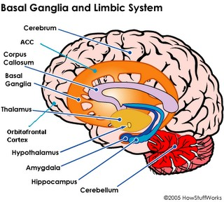
An analogy: Just as a basketball player has to learn some specific skill sets to facilitate virtuosity in playing the game, so people in recovery need to be taught effective tools for managing their disease. One way to teach these specific skill sets is by both learning and also by consistent practice of the performance of various routines (i.e., “games”) to exploit and rehearse the behaviors that are designed to foster both clarity and reliability in executive functioning.
3.

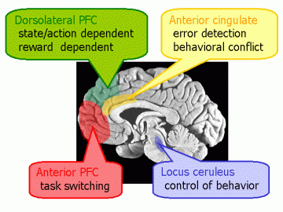

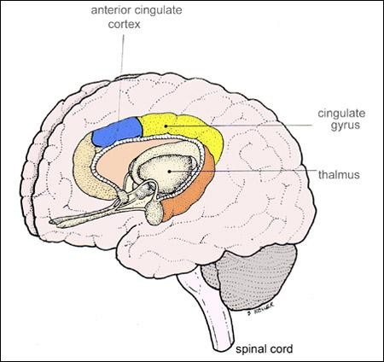

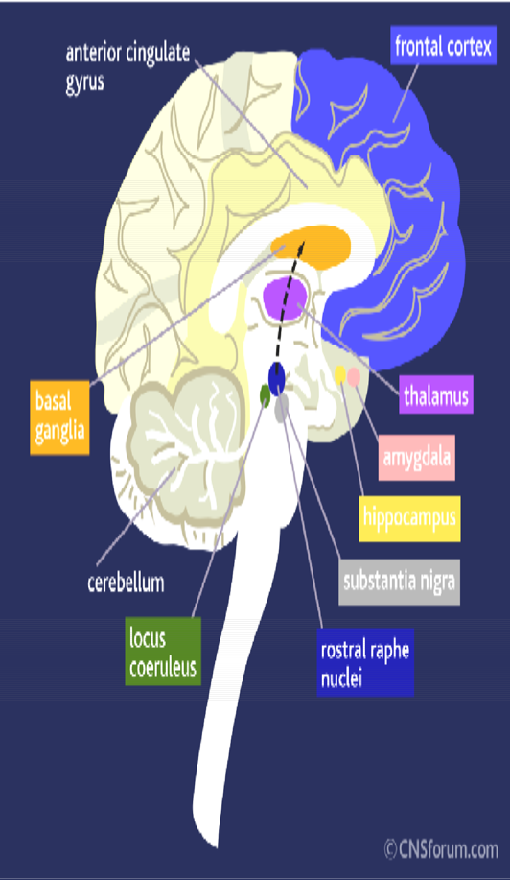

The anterior cingulate cortex is involved in emotional drives, experience and integration. Associated cognitive functions include inhibition of inappropriate responses, decision making
and motivated behaviors.

The dorsolateral prefrontal cortex processes information such as integrating different
dimensions of cognition and behavior, e.g., the ability to maintain and shift set, planning, response inhibition, working memory, organizational skills, reasoning,
problem solving and abstract thinking.

4.

It is assumed that the orbitofrontal cortex enables ability to delay one’s response to

an impulse (evoked in the Games by an invitation).

It should be remembered that to decline to do something you’ve considered doing is an action in itself, an action which is different from not doing something because you haven’t considered doing it.

The orbitofrontal cortex (OFC) helps maintain the integrity of repetitive behavior, to manage impulse control, to monitor ongoing behavior, to monitor behavior deemed socially appropriate, to gauge value of rewards based on sensory stimuli and evaluating subjective emotional experiences.

5.

We now know of a universal brain deficit in addicts (described in the American Society of Addiction Medicine’s Long Definition of Addiction) that becomes most clearly conspicuous in those in addiction recovery. The cerebral cortex fails to signal with sufficient quickness and force to squelch the behavioral response to a cue. Dr. Jon Grant and others have demonstrated that those areas of the brain facilitating such delay are, at best, inartful in their ability to target specific cues with a delay response. In the event of a craving episode, the person is unable to summon the decisiveness and attentional focus to decline to respond to the trigger; in other words, they relapse.

Ernst Haas: Blurred Running Figures

The exercises with the games are strictly volunteer-driven, so their success depends on those who have “come to play.” Although we hope to have some fun practicing the games, the goals are deadly serious. People relapse if they have not learned how to delay responses to external or internal cues to use/drink/ gamble, etc.

Through specific and dedicated practice, these areas of the brain can, in many cases, attain improved activation quickness and vigor enough to forestall relapse. The faculty in question is generally referred to as inhibition, and its purpose is to enable the person to decline a behavior in the presence of an impulse to act.

Executive functions are those abilities of attention and concentration that allow us to perform, complete and then shift tasks. Norman and Shallice have outlined specific functions:
- Those that involve planning or decision making
- Those that involve error correction or troubleshooting
- Situations where responses are not well-rehearsed or contain novel sequences of actions
- Dangerous or technically difficult situations

6.

- Situations that require the overcoming of a strong habitual response or resisting temptation.
The exercises, or games, alluded to earlier have been used with actual inpatients and outpatients. The response has generally been very favorable, as long as the participants understand two points:
That no intention is made to make light of these deficits and
That practice brings enhanced skill.

In one manner or another, these exercises give expression to areas of the brain which act as our “brakes,” allowing us the option of declining to do something. Other, related areas also empower us to concentrate on the task before us and to disregard distractions.
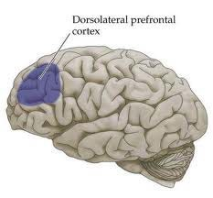

The real-world utility of these skills can be demonstrated in an addict’s being able to discern triggers to use and, concurrently (rather than simultaneously) to decline the act of using. The faculty of people being able to focus attention specifically to what they are doing regardless of what is happening around them can bring about a minor miracle: being triggered to use and - - not but - - not doing so.

OUTRO

That’s our podcast for today. If you’d like one hour of CE credit for just $5.00, you can go to the School’s website, cadaschool.com, click on “online courses,” and just follow the instructions. Once you pass the post-test, which includes evaluation questions, you’ll be able to download and print your certificate of completion. Be sure and stay in touch on Facebook! See you next time!

¹ Grant JE and Potenza MN. Impulse control disorders: clinical characteristics and pharmacological management. Annals of Clinical Psychiatry. 2004;16:27-34.

² Norman DA and Shallice T. Attention in action: willed and automatic control of behavior. In M
Gazzaniga (ed.): Cognitive Neuroscience: A Reader: Blackwell, 2000.

7.

