School of Addiction
and Behavioral Health

Educational Activity:
“There Is Only One of Me”

Just by dint of being alive and active in the world, all of us are, from time to time, drawn into the tendency to get over-revved and frenetic and to become overstimulated and over extended. That’s certainly not a pleasant or productive way to live, and it can lead to disaster for people in recovery!

INTRO

Hello, everyone, and welcome to our podcast! We’re coming to you from our studio at the Council on Alcoholism and Drug Abuse of Northwest Louisiana! I’m your host, Kent Dean, CADA’s Director of Clinical Development. Today, we’re discussing what is coming to be known as mindfulness and its value in helping us slow down and re-focus as often as needed during the day. To that end, we’re advocating something of a “manifesto” affirming good mental hygiene. You’ll be able to earn one contact hour of continuing education by completing the post-test after you listen to the program. We’ll give you instructions on how to do that at the end of the show.

What follows is a sort of “manifesto” I use to remind myself of my limitations, in which I can, almost paradoxically, enjoy greater productivity, serenity, and balance. I commend it to you for your consideration.

I have only one brain.
I am the only person who can use this brain I’ve been given. Therefore:

I can pay attention to only one thing at a time.
Human beings do not actually multitask, so I reserve forever the rights to pay attention as carefully as necessary for understanding the world around me and to refocus my attention as often as needed during the day.

1.

In an article in Psychology Today, Dr. Nancy K. Napier notes: “Think you’re good at doing several things at once? Reading and listening to music? Driving and talking on the phone (hands-free, of course), or texting while sitting in a meeting? Think again.

“Research in neuroscience tells us that the brain doesn’t really do tasks simultaneously, as we thought (hoped) it might. In fact, we just switch tasks quickly. Each time we move from hearing music, to writing a text, or talking to someone, there is a stop/start process that goes on in the brain.

“That start/stop/start process is rough on us. Rather than saving time, it costs time (even very small micro seconds). It’s less efficient, we make more mistakes, and over time, it can sap our energy.” ¹
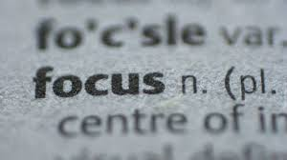

I can think only one thought at a time.
Even if it seems that I’m thinking several thoughts at once, I’m really only focusing on one at a time. Therefore:

I must reserve forever the rights to think as carefully as necessary for clear thinking and to refocus my thinking as often as needed during the day.
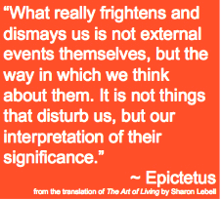

I can feel only one emotion at a time.
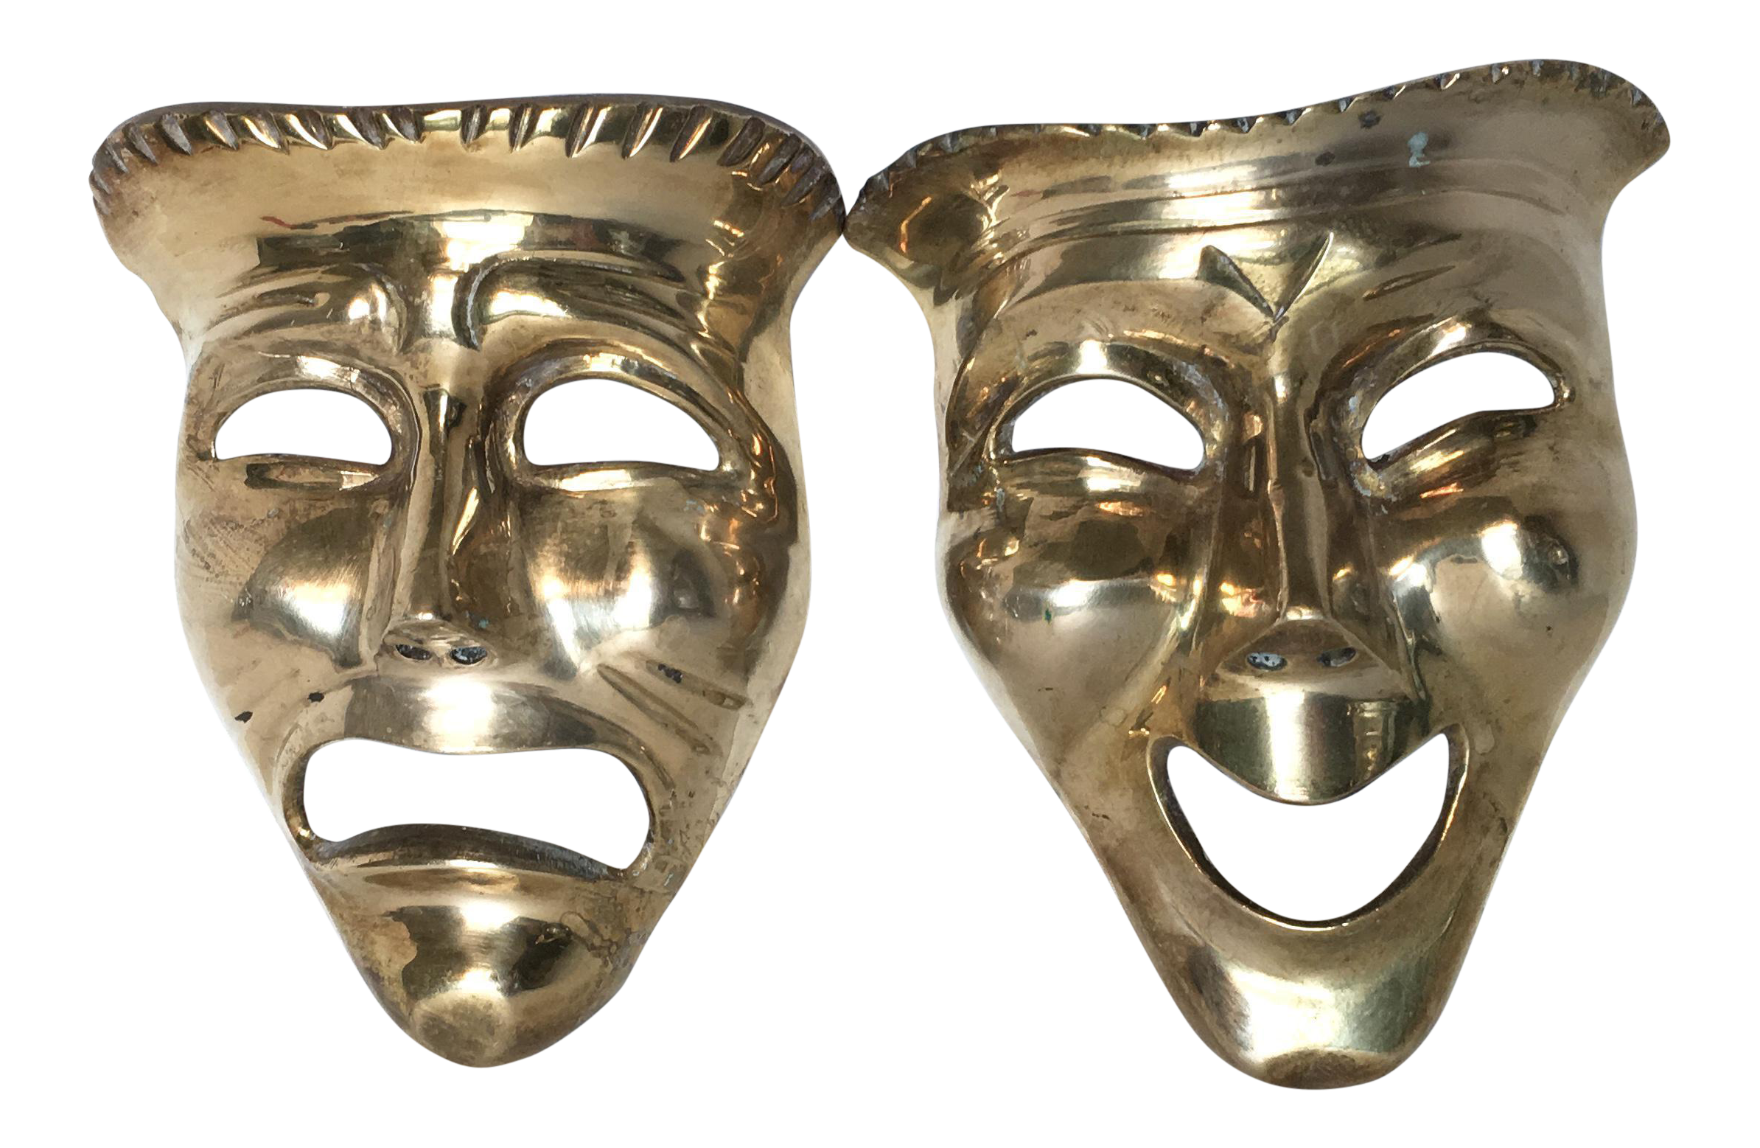
Since our emotions are heavily influenced by what we’re thinking, my moment-to-moment emotional state is influenced by my understanding of what’s happening right now. Therefore:

I must reserve forever the rights to identify my
feelings as carefully as necessary for balanced
emotions and to refocus my emotions as often
as needed during the day.

2.

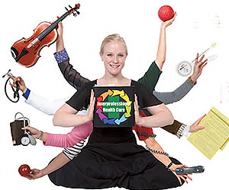
I can do only one thing at a time.
I can carry out only one task at a time.

Therefore:

I must reserve forever the rights to pace myself as slowly and carefully as necessary for organized behavior and to refocus my actions as often as needed during the day.

I can be in only one place at a time. My physical body is encompassed in my current location; wherever I am, I’m always “right here.”
Therefore:

I ask myself the question: "Here, at this place and in this moment, am I where I am supposed to be, and am I doing what I am supposed to be doing?”

As long as the answer is "yes," I cannot relapse.
If the answer is "no," I can always go to where I’m supposed to be and do what I’m supposed to be doing. Therefore:
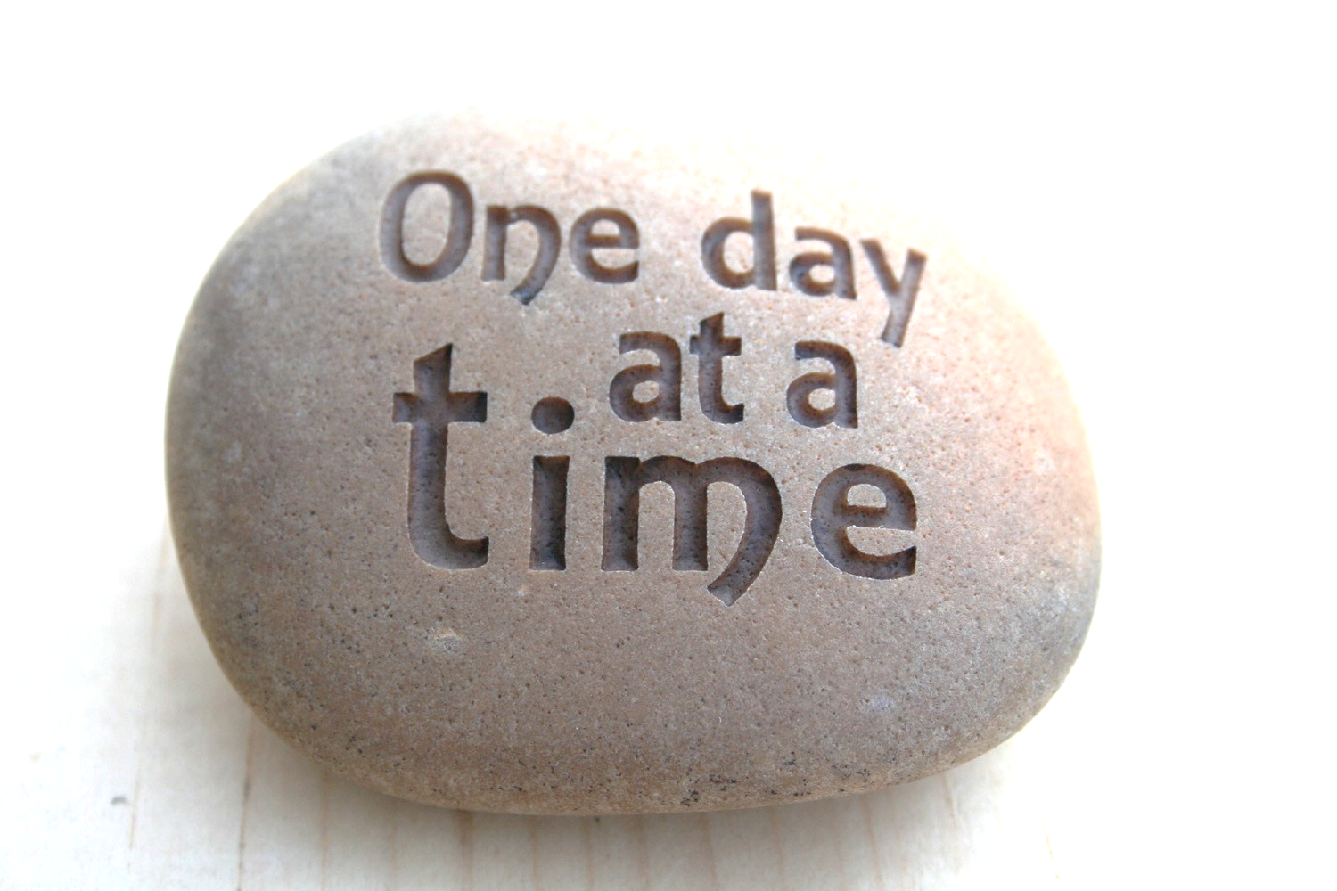
I must reserve forever the right to return to my schedule.

I can live in only one day at a time. It’s always “right now.” It’s always today. Therefore:

I must reserve forever the right to “restart” my day as often as needed during the day for reliable serenity.

At the Mayo Clinic website, the unidentified staff writers describe simple ways to cultivate mindfulness:
- Pay attention. It's hard to slow down and notice things in a busy world. Try to take the time to experience your environment with all of your senses — touch, sound, sight, smell and taste. For example, when you eat a favorite food, take the time to smell, taste and truly enjoy it.
3.

- Live in the moment. Try to intentionally bring an open, accepting and discerning attention to everything you do. Find joy in simple pleasures.
- Accept yourself. Treat yourself the way you would treat a good friend.
- Focus on your breathing. When you have negative thoughts, try to sit down, take a deep breath and close your eyes. Focus on your breath as it moves in and out of your body. Sitting and breathing for even just a minute can help.

The writers also recommend more-structured mindfulness exercises, such as:
- Body scan meditation. Lie on your back with your legs extended and arms at your sides, palms facing up. Focus your attention slowly and deliberately on each part of your body, in order, from toe to head or head to toe. Be aware of any sensations, emotions or thoughts associated with each part of your body.
- Sitting meditation. Sit comfortably with your back straight, feet flat on the floor and hands in your lap. Breathing through your nose, focus on your breath moving in and out of your body. If physical sensations or thoughts interrupt your meditation, note the experience and then return your focus to your breath.
- Walking meditation. Find a quiet place 10 to 20 feet in length, and begin to walk slowly. Focus on the experience of walking, being aware of the sensations of standing and the subtle movements that keep your balance. When you reach the end of your path, turn and continue walking, maintaining awareness of your sensations.²

Well, that’s the long version of my “manifesto.” Here’s the short version without any commentary:

I have only one brain.

Therefore:

I can pay attention to only one thing at a time.
I can think only one thought at a time.
I can feel only one emotion at a time.
I can do only one thing at a time.
I can be in only one place at a time.

Therefore:

I ask myself the question: "Here, at this place and in this moment, am I where I am supposed to be, and am I doing what I am supposed to be doing?”

As long as the answer is "yes," I cannot relapse.

If the answer is "no," I must reserve forever the right to return to my schedule.

I can live in only one day at a time.
It’s always “right now,” and it’s always “today.”

4.

OUTRO

That’s our podcast for today. If you’d like one hour of CE credit for just $5.00, you can go to the School’s website, cadaschool.com, click on “online courses,” and just follow the instructions. Once you pass the post-test, which includes evaluation questions, you’ll be able to download and print your certificate of completion. Be sure and stay in touch on Facebook! See you next time!

____________________________

¹ Napier, N. The Myth of Multitasking. Psychology Today. Sussex Publishing. 2020.
https://www.psychologytoday.com/us/blog/creativity-without-borders/201405/the-myth-multitasking

² Mayo Clinic Staff: Mindfulness Exercises. Mayo Foundation for Medical Education and Research. 2020.
https://www.mayoclinic.org/healthy-lifestyle/consumer-health/in-depth/mindfulness-exercises/art-20046356

5.

