School of Addiction
and Behavioral Health

Educational Activity:
PHOCH: The “ABCs” of
Risk Management in Addiction Recovery

INTRO

How do we make sense of the world around us? At any given moment, what criteria do we use to figure out whether or not we’re safe? And if we get it wrong; when we’re in actual danger when we only think we’re safe, what can the consequences be? Recovery in addiction makes it essential that the person understand and deal effectively with the risks and rewards of living a sober life in the real world.

Hello, everyone, and welcome to our podcast! We’re coming to you from our studio at the Council on Alcoholism and Drug Abuse of Northwest Louisiana! I’m your host, Kent Dean, CADA’s Director of Clinical Development. Today, we’re looking at some helpful ways that recovering people can size up their day-to-day world and make intelligent, safety-reinforcing decisions in the course of each day. You’ll be able to earn one contact hour of continuing education by completing the post-test after you listen to the podcast. We’ll give you instructions on how to do that at the end of the show.

P H O C H

If you will, please visualize or write down the following letters: “P,” “H,” “O,” “C,” and “H.” Now, these five letters form a word that is not an anagram; the letters are not merely moved around in a different order. No, these five letters, “P,” “H,” “O,” “C,” and “H”, exist as a re-spelling of an actual English word using normal sounds found in the English language. When you sound these five letters in the intended way, you’ll hear the actual, intended word clearly.

Here are a couple of clues: This actual word is a common, everyday, one-syllable English word; it's not slang, and it's not profanity. It's an animal; in fact, it's an animal that many people on the planet like to eat.

While you're working on deciphering this puzzle, please be especially conscious of the kind of thinking you're using to figure it out; that kind of learning, that sort of awareness is the point of this exercise.

1.

Well, you’ve figured it out, right? Can you now see the word for what it is?

Let’s decode it. We can recognize at least two common sounds in the word: “PH,” which can sound like “F” (as in Philadelphia) and “CH,” which can sound like “SH” (as in Chicago).

P H C H
\ / \ /
“F” as in “Philadelphia” “SH” as in “Chicago”

Of course, the word sounded by these letters is “fish.” That's all well and good for me to say that, but what does the “O” sound like to make a normal, everyday English word? How can the letter “O” sound like the “I” in “fish”;

Is there a word in English where "Ō" sounds like "Ĭ?" The only word I know of--there must surely be others--is the word “women.”
O
“Ĭ” as in “Women”

So, there you have the solution to deciphering this puzzle. Did you see? Things are not always as they seem.

What's more, be aware that, by taking you through this puzzle, I've played a little bit of a trick on your brain: Learning has taken place. Connections have been facilitated that were not there before you saw this puzzle. Your conscious awareness has moved, if only very slightly, from what it was previously.

For the rest of your life, if ever again you're confronted with the letters “P-H-O-C-H,” you won't look at them in exactly the same way again. No, you'll forever remember that they can sound the word "fish."

Psychologist Albert Ellis (1913-2007) credited the first-century philosopher, Epictetus, with the basic understanding for what he came to call Rational Emotive Behavior Therapy (REBT), which he began formulating in the 1950s. Much of the material in this piece is actually informed by his and his associates’ work.

From Epictetus to Ellis, sages have been reminding us that there’s value in objectivity when something’s bothering us in the here and now. Epictetus and Ellis would assert

2.

that we don't necessarily have to become upset about something if we can merely decipher the situation as it is in reality (at least for now). That's a very valuable aid to mental hygiene in many cases and a point well-heeded, but, oddly enough, in active addiction, the contrary is often at least as true:

There are times when addicts’ brains play tricks on them and cause them to undervalue, to misinterpret as excitement, some potential dangers because primitive parts of their brain stage an insurrection against their free will and sound memory and influence them to do things they might well regret later on.
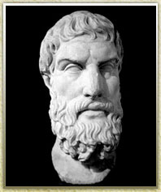

Epictetus (55-135)

As Epictetus’ student, Arrian, quoted him, “We are not disturbed by events but by the views which we take of them.” As we might say it today, “Mind over matter. If you don’t mind, it doesn’t matter.”

Let me recount for you Dr. Ellis' “A-B-Cs” of REBT.

What follows is a sequence of events. Now, that phrase, “sequence of events,” is important to remember because, you see, we’re dealing with the sorts of things that happen because the thing before them happened.

Remember: The items in this “A-B-C” sequence of events don’t happen in and of themselves. As you'll see, they happen because the thing before them happened.

“A” stands for Activating Event. In other words, something happens. (That “something” can be external, or it can be internal, such as a memory or an emotion ... or, as we'll see later, a craving episode.)

We’ll skip over column “B” for a few moments. We’ll need to return later to look at it in some detail.

“C” stands for the Consequence NOT of “A,” the Activating Event, but of this mysterious column “B.” The Consequence is comprised of two sub-events: Emotion, what we feel, and Behavior, what we do …

or what we decline to do.

Here's an illustration: I’m walking along outside in the woods one fine day, looking at the

3.

scenery and enjoying the fresh air, living in the moment. Not a care in the world that I’m aware of.

All of a sudden, I see a bear there, twenty feet away from me, looking at me. I stop suddenly. I can report to you that, in the here and now, at just this time, this moment, this second, the first thing I become aware of ...

the first thing I become aware of ...

is that I feel afraid.

If you’re following along on this sequence of events, you’ll quickly see that my feeling afraid is not the first thing that happens after I spot that bear in the woods.

To put it another way: I’m not afraid because I see the bear in the woods. I’m afraid because of that important, mysterious “Something”--in Column “B”--that happens in a momentous instant after I see that bear in the woods.

Because I feel afraid, I run away from the bear ... futile as that may be, since my understanding is that bears are faster runners and better climbers than any human being. (Well, he’ll have to work for his lunch, because, believe me, I'm getting myself out of here!)

Ok, here’s other scenario. I'm walking along outside in the woods on another fine day, once again looking at the beautiful scenery and enjoying the fresh air, living in the moment. Not a care in the world that I'm aware of.
All of a sudden, I see a bear there, twenty feet away from me,
looking at me. I stop suddenly.

This time, I can report to you that, in the here and now, at just this time, this moment, this second, the first thing I become aware of ...

the first thing I become aware of ...

is that I feel excited!

Once again, you can easily see by this sequence of events that my feeling excited is not

4.

the first thing that happens after I spot that bear in the woods. In other words, I am not excited because I see the bear in the woods.

No. I am excited because of that momentous, mysterious “Something”--Column “B” again--that happens instantly after I see the bear in the woods.

Because I feel excited, and because I obviously haven't learned otherwise, I run toward the bear to examine him! (Thanks, but I believe I'll decline!)

It's probably becoming obvious what's in the column marked “B.” I'm now thinking about the situation. I'm trying to decipher, to interpret, the situation, to make sense of it in terms of my understanding of what's reality and what's not reality.

Whether or not I’m afraid or excited by that bear in the woods has to do with my Beliefs about the situation: what I've learned about the situation, how I look at it. If you're aware of the belief that “This bear is dangerous to me," you'll naturally be afraid and want to turn and run away from him.
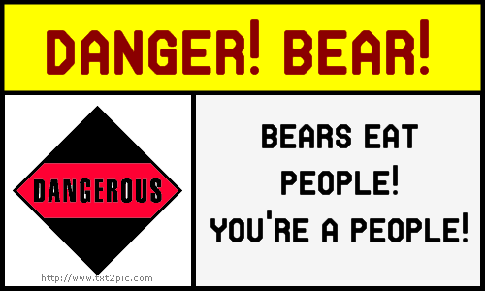

If, on the other hand, you believe "This bear is safe to me,” you may yield to your natural curiosity and move to go get a closer look!

Why would you fear the bear? Well, maybe you've had a bad experience with a bear in the past. Maybe it's just that you've looked at National Geographic or seen TV shows about bears and what formidable predators they are.

One way or the other, though, your beliefs about the bear arise from what you've learned about bears, what you remember about them and your overall understanding retrieved from your stock of information about bears, people and possible dangerous effects of interaction.

Now here is a key point to recall, though: Your understanding of the reality about bears (or about anything else, for that matter) can be right or it can be wrong. If you fear the bear, that doesn't necessarily mean there's automatically something to fear.

5.
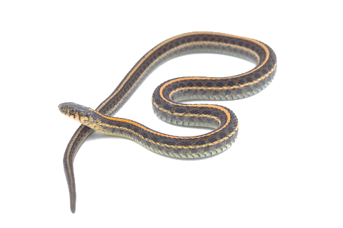
Have you ever known someone with a phobia about snakes? They can't be in the same room with a snake, even a harmless garter snake.

It's clear that their beliefs about
the danger inherent in such
harmless creatures are not in
contact with reality; nonetheless,
the automatic, learned reaction is
still there, and it can be changed
only with new information and with
continuing practice for the person to become desensitized.

On the other hand, if you have no fear of the bear, it doesn’t automatically follow that you’re safe. You may have no fear because your ability to see reality is impaired then, either by lack of learning about bears (simple ignorance), by alcohol or other drugs or--yes--by plain old, garden-variety denial.

Becoming desensitized to this threat could prove fatal!

You say, “Bears are soft, furry and cuddly! No! ... Stop! Bears are vicious predators!” ... Well!? ... Which is it, then?? What should I believe? What can I do??

Remember ... Things are not always as they seem.

Your belief about a situation may be right ... or it may be wrong ... you may even be ambivalent (have mixed feelings) about the situation.

In a potentially dangerous situation, people have to act consciously in ways that provide the highest likelihood of sustaining their well-being.

You have to learn the value of appropriate risk, which might well mean “staying on the side of goodness” and using appropriate caution in declining to interact with unfamiliar situations.

So ... Here you are right now ... socially drinking every so often ... and the quietly-subversive message from your limbic system, the wanting part of your brain, smack inside the middle of your head, is:

“Dispute? Why? There’s no problem here ...! It’s just that ... somewhere here, in the back of my mind ...”

“I’m not so concerned about whether bears are safe or dangerous. I am concerned to know if it’s safe for me to take a drink, or is it too much of a risk for me personally?”

Fortunately, we have a part of our brain which helps us decipher seemingly-contradictory situations:

6.

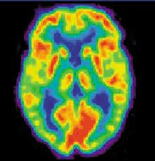

The anterior cingulate cortex (ACC) has components that help us think through the consequences of every action we take … if, that is, we take the time to do the thinking-through.

In any situation in which people have to size up and decipher to gauge its potential for danger, the only safe course is to assume that the situation is dangerous unless and until it is proven beyond a doubt that it is safe. In other words, if you’re going to make a mistake, always be sure and make it on the side of being as careful as possible.

OUTRO

That’s our podcast for today. If you’d like one hour of CE credit for just $5.00, you can go to the School’s website, cadaschool.com, click on “online courses,” and just follow the instructions. Once you pass the post-test, which includes evaluation questions, you’ll be able to download and print your certificate of completion. Be sure and stay in touch on Facebook! See you next time!

7.

