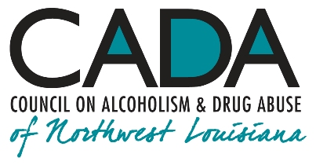
School of Addiction
and Behavioral Health

Educational Activity:
Into Action: How People Change

INTRO

Recovery in any chronic mental illness is an ongoing, lifetime process, one that is more than merely "getting over" an episode of the illness. Like every other mature adult, people in recovery are always changing, in the process of becoming more mature versions of themselves. The advent of the art and science of promoting those changes was one of the most remarkable innovations in the field of behavioral health of the 20th Century, answering some very basic questions about how people envision and implement change.

Hello, everyone, and welcome to our podcast! We’re coming to you from our studio at the Council on Alcoholism and Drug Abuse of Northwest Louisiana! I’m your host, Kent Dean, CADA’s Director of Clinical Development. Today, we’re discussing the pattern of dawning awareness that allows people to make changes in their lives. You’ll be able to earn one contact hour of continuing education by completing the post-test after you listen to the program. We’ll give you instructions on how to do that at the end of the show.

Recovery itself begins with admitting there’s a problem. The person must give up the thinking that there is nothing wrong (denial) and begin taking stock of how the disease has affected their lives and their loved ones’ lives and to become educated on the nature of the disease and its daily management. The courageous step of acknowledging a problem often depends on the help of a professional therapist and a support group. The discipline of recovery can be taught easily enough; the difficulty lies in the acceptance of the need for ongoing, lifetime recovery.

1.

To illustrate how people make changes in their lives, let me tell you an anecdote about something that happened to me several years ago. One beautiful afternoon, I was driving on an interstate to go to a conference. I remember entering the highway noting that the weather is what pilots call “severe clear,” the visibility stretching all the way to the horizon. As the song says, on this clear day, you really can see forever. I drive on for several miles with not a care in the world, marveling at the beautiful weather.

At some point, it seems to me that there begins to be something just a little, how to say it … different … “off” … about the horizon. It’s the same as it has been, and yet, it’s not the same as it seemed just a few moments ago. Something is different somehow. I think to myself, “If I stop here, turn around, and go in the opposite direction, I might even believe that what I think I’m seeing is just an optical illusion, maybe heat waves bending the light as they rise off the road on a hot day.” Except that it isn’t a hot day; the temperature’s in the low 40s. “So much for that theory,” I remember thinking.

I’m going on about all this at such length because I’m trying to impart to you the gradualness with which my brain is cluing me in as to the situation at hand. Since I don’t turn around and am still moving in the same direction, I come to see that, in fact, there is something different about the horizon I’m seeing now. I hadn’t expected to see anything out of the ordinary when I started out this morning, so, for a long time, it’s hard to come to believe that something is actually amiss. Now, it’s undeniable: I’m having an “uh oh” moment about this “thing” on the horizon, and I’m now about to embark on a sort of “neurological teleconference” that will ultimately save my life. “What is going on here?” part of my brain is signaling to another part, in the back of my consciousness. (Literally behind my conscious awareness: this preliminary communication is happening between my amygdala, hippocampus, and some other players.)

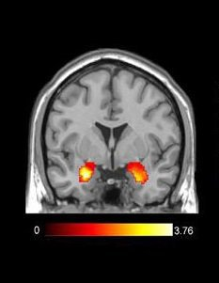
And now I get a clear, conscious message from my threat center, my two amygdalae: “We have a problem. Danger.”

I query them, “What’s the problem?”

They whisper: “We have a problem. Danger. We don’t know what’s wrong, but there’s a problem. Danger.”

I respond, “If you don’t know what the problem is, why should I believe you that there is one?”

I get an answer: “Danger. There’s a problem. Danger.”

I respond, “Fine. Ok. There’s a problem, and you don’t know what it is, right?

“Danger. There’s a problem. Correct. We don’t know what’s wrong, but there’s a problem. Danger.”

2.

“Well, what am I supposed to do about it?”

“Danger. There’s a problem. We don’t know; that’s not our job. Danger. There’s a problem. We’re forwarding this message to your front brain. Danger. There’s a problem. Danger.”

“Why do you keep telling me there’s a problem?”

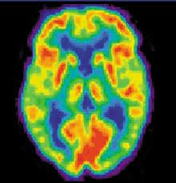
“Danger. There’s a problem. Because it keeps being true. There’s a problem. Danger.”

“Oh! Well, thanks for letting me know!”

“Danger. There’s a problem. Danger.” [They will
reiterate this single message repeatedly until I’m
out of danger later.]

I tune into my front brain (FB), a center of reasoning and judgment, and my anterior cingulate cortex (ACC), which, among other functions, helps me decipher contradictory situations. “FB and ACC, how about you? Got any ideas about what I should do about this ‘thing’ on the horizon?”

My front brain suggests, “Might want to ease up off the gas a little.” My ACC says, “I can’t tell yet if it’s safe or dangerous. Better assume the worst until we know better.”

“Why ease up off the gas?”

It says, “Think this through, Kent. You’re traveling 70 miles an hour in a 3500-pound vehicle, and your visual cortex is sending me information that the … ‘thing’ on the horizon seems to have gotten a little bit bigger in the last couple of minutes. Although you’re going 70, it’s not certain that it’s moving at all.”

Well, now I’m literally alarmed, so I do what my FB tells me to: I slow down just enough not to be a hazard to the cars behind me. I still don’t know exactly why I’m slowing down, except that I believe and feel that I need to. I have the sense of being in potential danger because my brain is alerting me that I am. In my newly-alerted state, I continue to travel toward this ever-so-slowly-growing “thing” on the horizon.

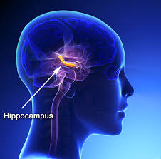
“So then what do I do, FB? Can you come up with a plan?”

3.

“Yes, but I need more information. Let’s get your hippocampus [a center of learning and memory] to pull some information about what you did last time you were in a situation like this. HC? What do you have for us? … Ok, got it. Thanks! HC’s telling me that the last time you were in a situation like this, an 18-wheeler had blown a tire. That time, you slowed down and carefully went around the tire debris in your lane.”
I press for an answer. “Ok, but I can’t really make out just what’s in the lane just
yet. What do I do?”

My front brain reminds me, “I can’t know yet, Kent. We need to consult your
visual cortex in the back of your brain. VC, what do you see?”
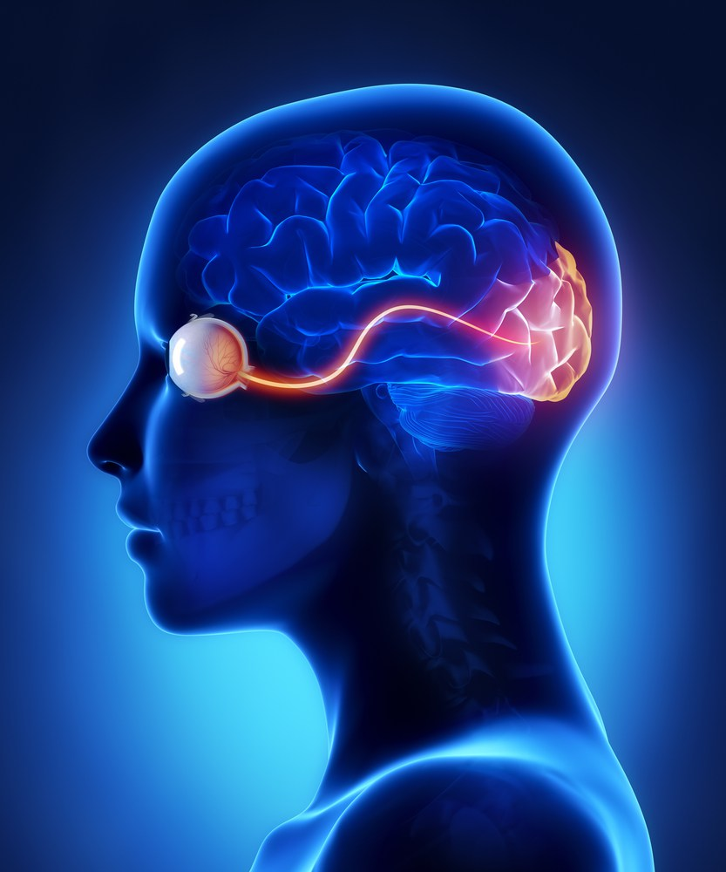

My visual cortex (VC), a vision-processing sheath of neurons in my occipital lobe, responds, “Scan the scene with your eyes.” [FB and ACC chime in: “Look for anything out of the ordinary.”] … “Ok,” says VC. “I have it. I see a … some sort of cage-like structure, but I can’t make out what it is … but I’m beginning to be able to see enough to tell me that it’s really big!”

“Not good, says FB. “How big is it, VC?”

“It seems to be enormous, like it takes up the entire lane we’re in!”

“Um … you are slowing down, aren’t you, Kent?”

“Yes, FB.”

“Good! Thanks, VC! Hey, HC! Quick! Do you have anything on evading a cage-like structure taking up a whole lane of an interstate highway?”

My Hippocampi reply, “Hang on … Looking … No … just a lot of ‘blown-tire’ and ‘disabled vehicle’ stuff. And some police traffic management at an accident where somebody ran off the road. Sorry, that’s all I have to send you at the moment.”

FB says, “Thanks for trying, HC! Kent, we’re going to have to extrapolate a bit from that time you evaded a blown truck-tire. Remind him of that incident, please HC.”

4.

My hippocampi comply, so I recall navigating through an accident a few years back where someone had skidded off the highway.

My front brain continues: “What do you see now, VC?”

“Now it’s pretty clear that our whole lane is blocked by this ‘thing.’ ”

“Ok, Kent. From past experience, I know that we came through safely when you slowed down, got out of the lane you’re in, and—hey, VC, see any police?”

“Yeah. They’re everywhere, and they’re moving their arms and pointing.”

“Great! Thanks, VC! Educated guess, Kent, they’re probably directing traffic. Here’s the plan. We know what’s in your best interests, so, if you can do it safely, get into the other lane now. When you get to that ‘thing’ in the highway, follow the directions of the police on the scene really carefully. Do whatever they tell you to. They’ll get us through this ok. Got that?”

“Got it. Thanks, everyone!”

So that’s what I do. I slow down, get into the other lane, which is open to traffic, and we’re all guided through this obstruction by the police. What is blocking the lane is, indeed, a 15-foot-tall, metal, cage-like structure, the purpose of which I cannot begin to fathom. What is very clear to me is that, had I not listened to and heeded this inner conversation, and had I hit this “thing” at cruising speed, I’d’ve have been killed instantly. I received the right kind of help at the right time—from my brain as well as the State Police—and I was open to accepting and using it. Why was I open to accepting help? Because I saw doing so as being in my best interests. Before I knew it, we were all on our way again, heading down the highway without incident. It could have been a disaster, but it wasn’t. No injuries, no fatalities. Safe.

So let’s tie this experience in with how people change. In the late 1970s, two psychologists, James O. Prochaska and Carlo DiClemente (and, later, Wayne Velicer), formulated a progression of awarenesses and behaviors that they called the “Transtheoretical” or “Stages of Change” model. The Stages of Change are: Precontemplation, Contemplation, Preparation, Action, Maintenance, Termination, and, possibly, Relapse, which is no longer considered a specific Stage.

5.

Here’s a description of each of the Stages, paraphrasing the authors, along with the tie-in to my experience on the interstate:
Stage 1, Precontemplation: Not intending to take action in the foreseeable future. When I started out that morning, I was unaware there would be an obstruction on the highway. (The vehicle I owned then didn’t have GPS-assisted navigation.)

Stage 2, Contemplation: Beginning to recognize that current behavior is problematic and starting to look at the pros and cons of continued actions. As I traveled, I begin perceiving something different—a little “off”—about the horizon, and it began to dawn on me that I needed to consider doing something different than planned.
Stage 3, Preparation: Intending to take action in the immediate future and (maybe) beginning to take small steps toward behavior change. I note that a sense of threat, or alarm, was forming in my mind, and I marshalled my mental resources, my front brain, hippocampi and amygdalae, and my vision, to guide me through the impending danger.
Stage 4, Action: Making specific, overt modifications in behavior or in acquiring new healthy behaviors. I heeded what my mind was telling me, and I took specific actions—slowing down, moving into the unobstructed lane, and obeying the State Police—to move safely through the potential danger.
As for Stage 5, Maintenance, I do my best to practice defensive driving skills, including attention to road conditions and looking ahead to possibly dangerous situations further down the road.

Recovery is an entire process of being well, a lifetime collaboration with the illness rather than conflict with it. The threat isn’t typically a metal cage in the highway; it’s being unexpectedly confronted with a trigger to use or drink or gamble. Cultivating this model of change can guide people with addiction through dangerous situations so they come out the other side. No relapses, no fatalities. Safe.

OUTRO

That’s our podcast for today. If you’d like one hour of CE credit for just $5.00, you can go to the School’s website, cadaschool.com, click on “online courses,” and just follow the instructions. Once you pass the post-test, which includes evaluation questions, you’ll be able to download and print your certificate of completion. Be sure and stay in touch on Facebook! See you next time!

6.

