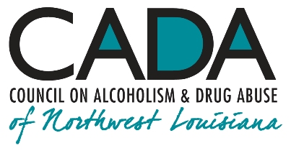
School of Addiction
and Behavioral Health

Educational Activity:
Harm Reduction and the “Good Samaritan”

INTRO

“Needle exchange programs only encourage addicts to keep on using!” “Giving wine to a homeless alcoholic is the worst kind of enabling!” “Methadone maintenance is just a racket to keep people hooked on opioids!” Are these and other harm reduction practices doing more harm than good or more good than harm? When it’s too late for prevention, is there a place for harm reduction in current addiction treatment?

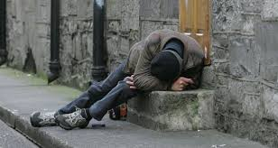

Hello, everyone, and welcome to our podcast! We’re coming to you from our studio at the Council on Alcoholism and Drug Abuse of Northwest Louisiana! I’m your host, Kent Dean, CADA’s Director of Clinical Development. Today, we consider harm reduction, which some see as abject enabling at best and even malpractice at worst. What, exactly, do these practices mean in the life of someone with addiction? You’ll be able to earn one contact hour of continuing education by completing the post-test after you listen to the program. We’ll give you instructions on how to do that at the end of the show.

We rightly pay attention to the “what” and “how” of harm reduction, but the “why” matters, too. A powerful illustration of the rationale behind “meeting people where they are” (i.e., harm reduction) comes from the parable of the “Good Samaritan.” “When asked, “Who is my neighbor” by a young, self-aggrandizing lawyer trying to trap Him into betraying presumed ignorance about Levitical codes, Jesus of Nazareth responds to this cant with a culturally-reverberant story about an unfortunate Jew and his quite-unexpected advocate, a Samaritan, two people who would normally violently despise one another (and with good reason). Jesus sets as the tale’s backdrop the infamous “Way of Blood,” the treacherous, crime-ridden route from Jerusalem to Jericho:

1.
"A certain man was going down from Jerusalem to Jericho, and he fell among robbers, who both stripped him and beat him, and departed, leaving him half dead. By chance a certain priest was going down that way. When he saw him, he passed by on the other side. In the same way a Levite (a “follower of the Law,” i.e., a common man of no ecclesiastical rank) also, when he came to the place and saw him, passed by on the other side.

But a certain Samaritan, as he travelled, came where he was. When he saw him, he was moved with compassion, came to him, and bound up his wounds, pouring on oil and wine. He set him on his own animal, brought him to an inn, and took care of him. On the next day, when he departed, he took out two denarii [equivalent to around $150 today], gave them to the host, and said to him, 'Take care of him. Whatever you spend beyond that, I will repay you when I return.' Now which of these three do you think seemed to be a neighbor to him who fell among the robbers?"

Levitical priest

He said, "He who showed mercy on him."

Then Jesus said to him, "Go and do likewise." ²

The Harm Reduction Coalition puts forth basic principles and philosophy about harm reduction in contemporary terms. The Coalition notes that harm reduction:

“Accepts, for better and or worse, that licit and illicit drug use is part of our world and chooses to work to minimize its harmful effects rather than simply ignore or condemn them.

“Understands drug use as a complex, multi-faceted phenomenon that encompasses a continuum of behaviors from severe abuse to total abstinence and acknowledges that some ways of using drugs are clearly safer than others.

“Establishes quality of individual and community life and well-being–not necessarily cessation of all drug use–as the criteria for successful interventions and policies.

“Calls for the non-judgmental, non-coercive provision of services and resources to people who use drugs and the communities in which they live in order to assist them in reducing attendant harm.

“Ensures that drug users and those with a history of drug use routinely have a real voice in the creation of programs and policies designed to serve them.

2.
“Affirms drugs users themselves as the primary agents of reducing the harms of their drug use and seeks to empower users to share information and support each other in strategies which meet their actual conditions of use.

“Recognizes that the realities of poverty, class, racism, social isolation, past trauma, sex-based discrimination, and other social inequalities affect both people’s vulnerability to and capacity for effectively dealing with drug-related harm.

“Does not attempt to minimize or ignore the real and tragic harm and danger associated with licit and illicit drug use.” ¹

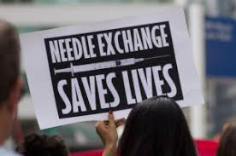
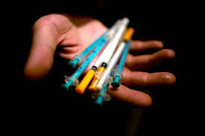

In Jesus’ parable, it isn’t implied that the Samaritan and the Jew befriend one another after the rescue or that the long-standing enmity between these two chronically-embattled cultures is affected in any decisive way. At one time or another, all of us have been in the position of both the Samaritan and the Jew: there but for the grace of God go any and all of us. (For that matter, whether or not we like to admit it, we’ve all also been in the position of the priest and the Levite, who, for reasons of fear of getting involved, slavish adherence to Levitical rules, or simple callousness, stayed as far away as they could from the hapless, maimed assault victim.)

The parable actually gains power if you assume that this particular act of kindness changes nothing in the wider realm of Samaritan-Jew relations and that some of Jesus’ hearers are undoubtedly scandalized merely by being exposed to such a scenario. Even more power can be ascribed to it if you assume that the relationship between that particular Samaritan and Jew is essentially unaltered by the Samaritan’s kind actions.

3.
The rescue gains resonance precisely because it “goes against the grain” in the way these two cultures view one another, their entrenched mutual bigotry notwith-standing: “When he saw him, he was moved with compassion, came to him, and bound up his wounds.” (Note also that the Samaritan offered more than just thoughts and prayers.) The point of the story is that the Samaritan meets the Jew where he is and validates his predicament as a non-judgmental starting point for rendering assistance, no questions asked, no expectations, no reimbursement received. It’s the right thing to do because it’s the humane thing to do.

We must do no less for those who’ve asked for our help, whether or not they adhere to cultural norms we believe are appropriate. Our job isn’t to reject or condone (both of which are judging) but to extend ourselves beyond the human barriers of cultural and racial prejudice and to rescue.
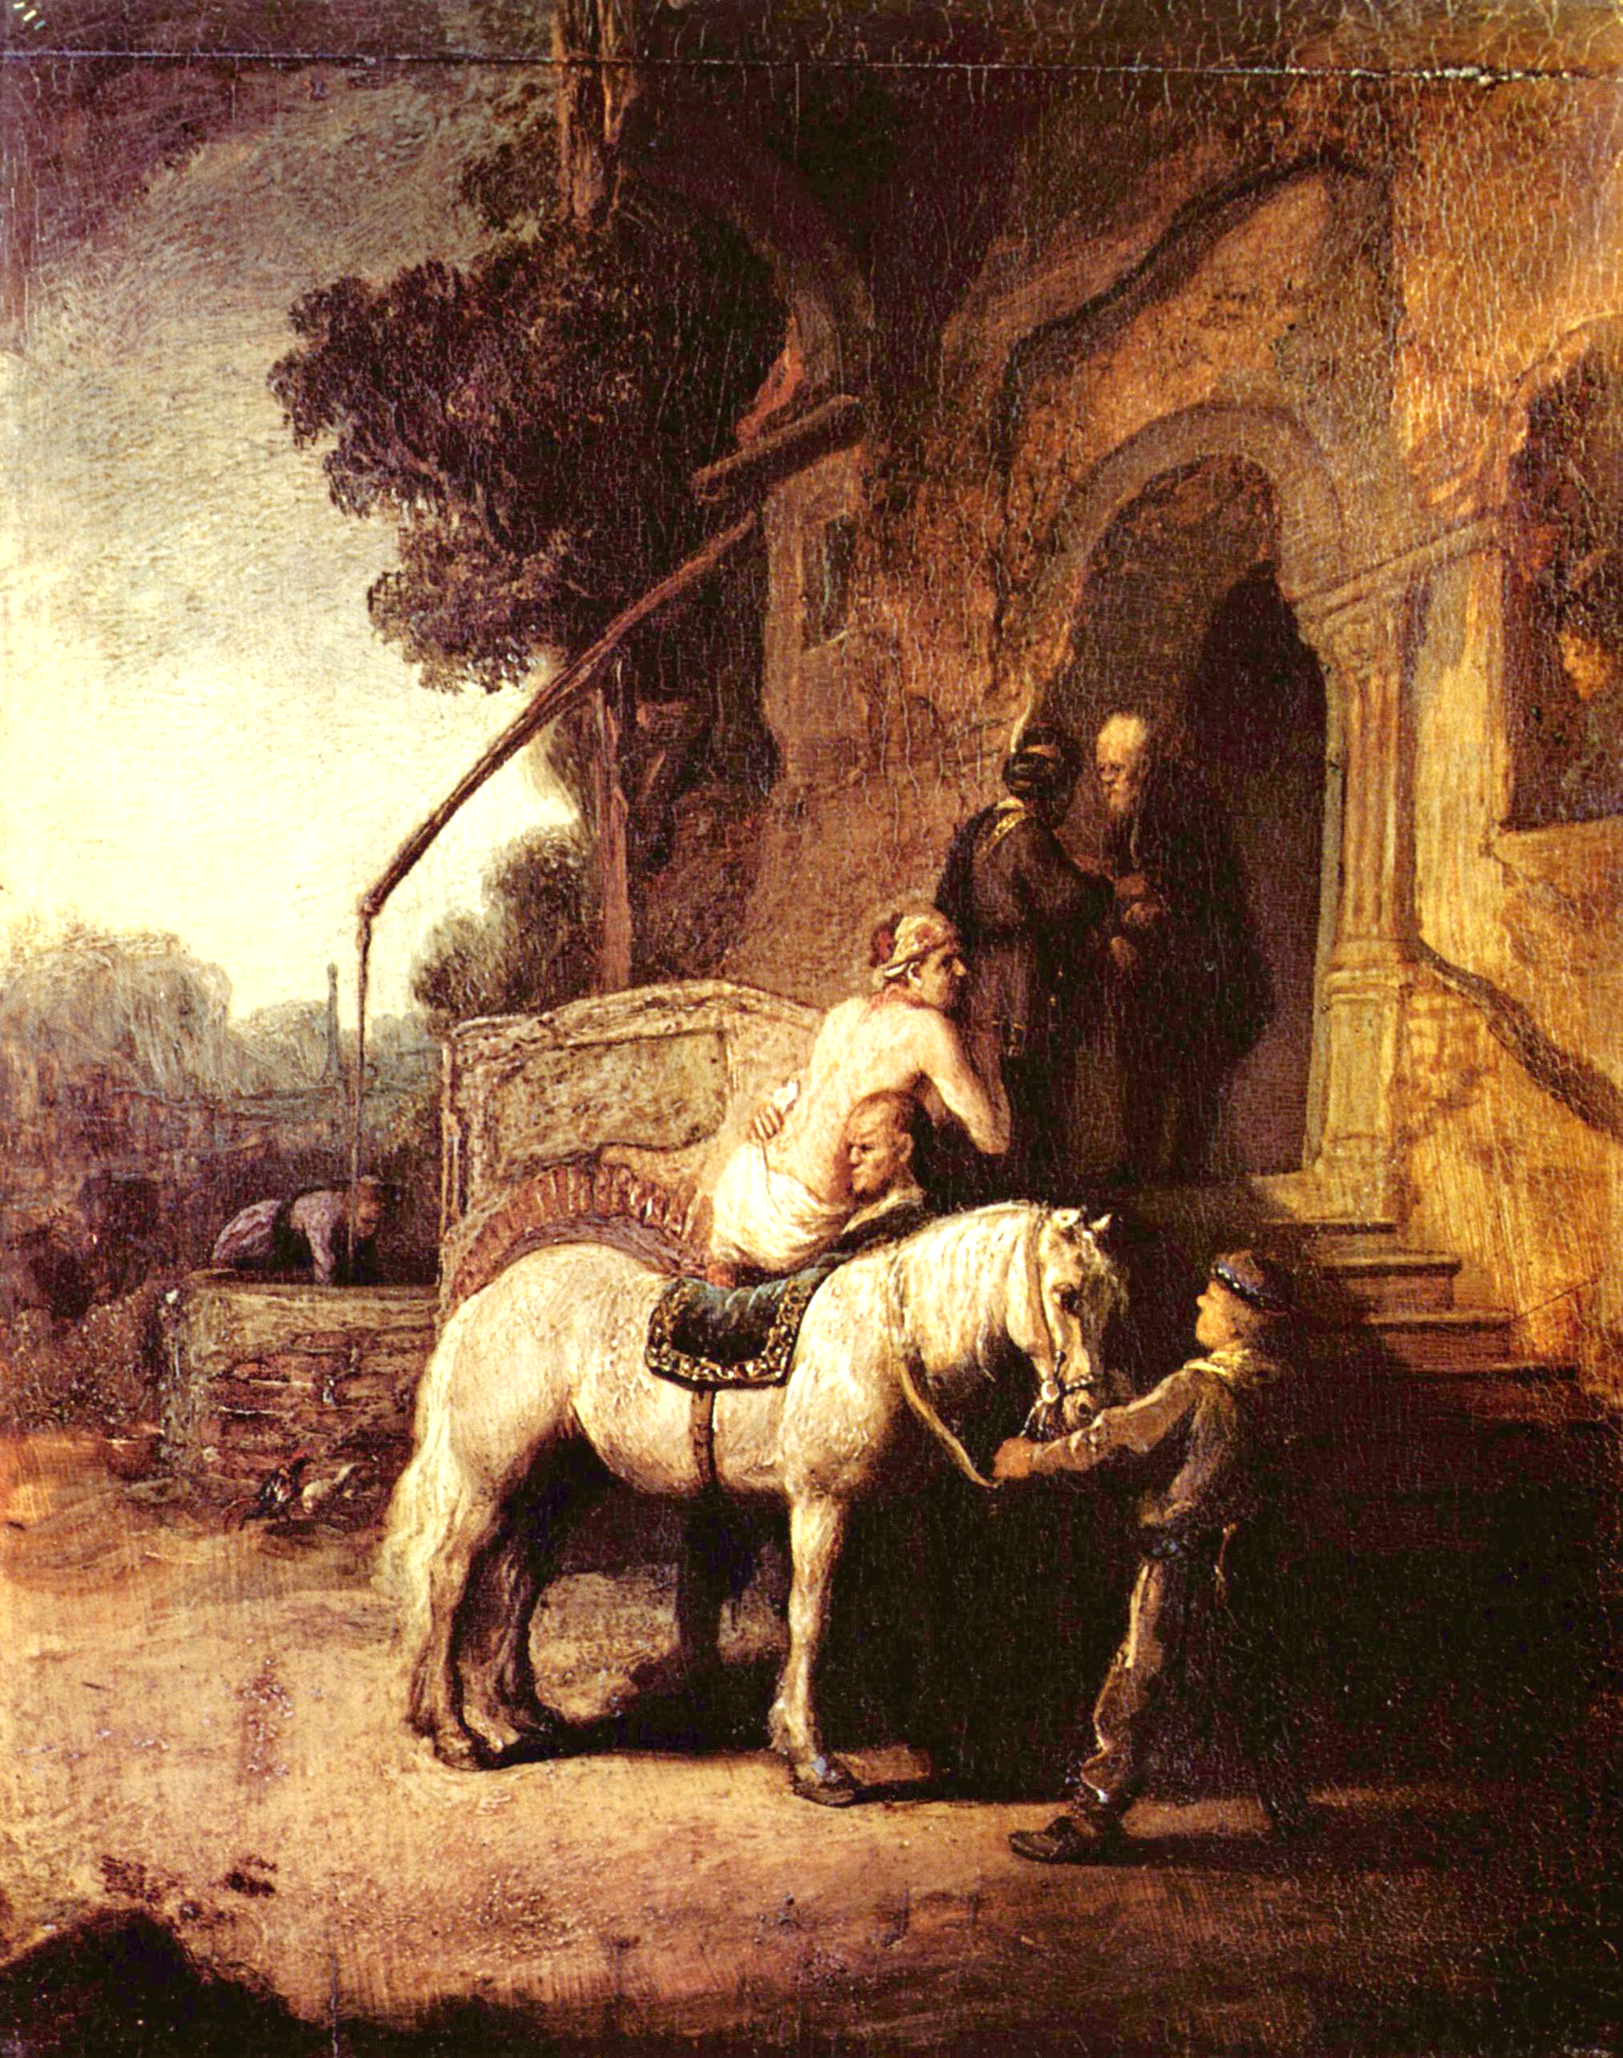

Rembrandt van Rijn (1606-1669)
The Good Samaritan (1630)
Oil on oak panel
24.2cm X 19.8cm
East Galleries I

OUTRO

That’s our podcast for today. If you’d like one hour of CE credit for just $5.00, you can go to the School’s website, cadaschool.com, click on “online courses,” and just follow the instructions. Once you pass the post-test, which includes evaluation questions, you’ll be able to download and print your certificate of completion. Be sure and stay in touch on Facebook! See you next time!

^{1.} http://harmreduction.org/about-us/principles-of-harm-reduction/

² Luke 10:30-37, World English Bible

4.

