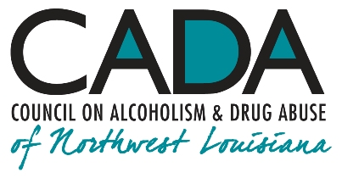
School of Addiction
and Behavioral Health

Educational Activity:
The Evolution of Addictive Disorders
From Sin to Disease

INTRO

Social drinking and recreational gambling have progressed from being seen by some simply as a sinful activity to our current understanding of chemical addiction and compulsive gambling (what we now term gambling disorder; not to be confused with recreational gaming) as related, treatable addictive disorders. In terms of wagering, it’s been a long road separating normal gaming from gambling addiction in the mind of the public. We’re not at the end yet; we can say, however, that the outlook for people with addictive disorders is far improved over what it was even a decade ago.

Hello, everyone, and welcome to our podcast! We’re coming to you from our studio at the Council on Alcoholism and Drug Abuse of Northwest Louisiana! I’m your host, Kent Dean, CADA’s Director of Clinical Development. Today we’re going to examine how the perception of addictive disorders has evolved from being a sinful lack of character to the recognition that addiction is a treatable brain disorder. You’ll be able to earn one contact hour of continuing education by completing the post-test after you listen to the program. We’ll give you instructions on how to do that at the end of the show.

So … on with the show!

Substance addiction (chemical dependence) and compulsive gambling are something completely different from social substance use and recreational gambling, so it’s important to have an understanding of the ongoing evolution of how addictive disorders are described clinically. This material (and the accompanying booklet, also available from CADA) has been assembled and scripted to give you a resource you can use in educating other people about addictive disorders.

1.

If you think about it, substance abuse and gambling don’t have very savory reputations! Consider, for example, this early depiction of gambling in Western culture. Jesus’ crucifixion is, seemingly, foretold in the Old Testament: “They divide my garments among them; for my clothing they cast lots.”

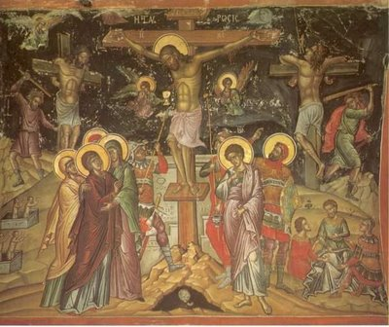

… and recorded in this New Testament reference
in which Roman soldiers wager to dive Christ’s
garments while He is still on the cross: “and they
crucified Him and divided up His garments among
themselves, casting lots to decide what each man
should take.”

Just think of all those hyperventilative sermons delivered by generations of “fire and brimstone” preachers! And eternal perdition is just what addicts have coming to them, too! Everyone knows that addicts are just bad people getting worse by the day!

2.

We’re going to eavesdrop on two situations, or scenarios, for your consideration. They are very different—in fact, essentially different—from one another, although to a casual observer, they appear identical. I’d like to clarify what I’m talking about.

Scenario One

Normal, recreational drinkers or gamblers go to a place where alcohol is served or where organized betting takes place. They enter the bar or gaming area fully conscious of their environment. They use the money they brought with them to buy alcohol or, possibly, to gamble in an attempt to win more money. They have one or two drinks, or if gambling, they win or they lose; then, at some point, they leave, having experienced the diversion of being teased with a chance of winning more money than they had when they came in. They give some thought to winning or losing, certainly, but they don’t obsess on it.
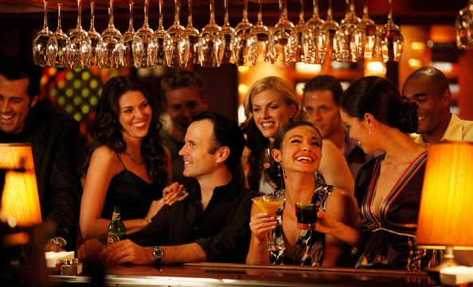

Scenario Two

In contrast, seemingly-normal, seemingly-recreational drinkers or gamblers go to a place where organized betting takes place in some form. A casual observer might think they were seeing a normal gambler entering the building to have some diversion, but let’s look at these people more closely.
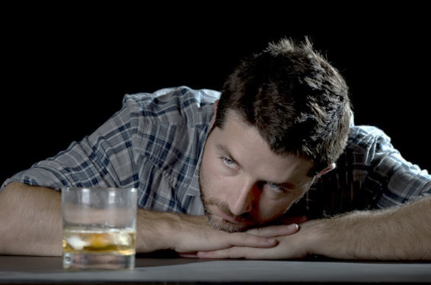

These people enter the bar or gaming area already partially disoriented, only marginally conscious of their environment—“zoned out,” so to speak—in what’s called a dissociative state (in other words, “unplugged” from the reality around them), and addictive gamblers have a fixed delusion that they can, will and must, ultimately, win.

3.
If compulsive gamblers do win, they’re triggered to want to play more to amass even more money. If they lose, they’re triggered to want to play more to get their money back. Given the odds of any competent gambling venue, they’ll likely leave having lost more—often much more—than they had when they came in.

If they lose, they’re triggered to want to play more to make up for the loss. They leave, having endured the agony of being teased with the enticement of winning more than they had when they came in. Similarly, picture the alcoholic who has run out, increasing his need to find more alcohol.

Much of society has frowned on alcohol or marijuana use or gaming in general and compulsive gambling in particular. Just imagine the challenge and stigma both to people affected with addictive gambling and to those who would help them when faced with such anger and, often, shaming.

Both groups of people and those observing them are generally unaware that an alcoholic or compulsive gambler is not and never has been a recreational drinker or gamer. Both groups of people are generally unaware that the person with an addictive disorder is handicapped by a pre-existing problem, the roots of which are there, hidden away deep in the middle of the brain, even before he or she ever takes the first drink or places the first bet. The problem may only recently have become detectable.

There’s recreational drinking or gambling, and then there’s addiction. To a casual observer, they look alike (at least in the beginning), but those two behaviors really have little in common. True social drinking and recreational gambling are done by conscious choice, so we say they’re volitional, or voluntary. Addictive drinking and gambling are done with impaired consciousness and choice, so we say they’re avolitional, or involuntary.

Compulsive gamblers, alcoholics, and other addicts are victims of an insidious and very powerful brain-based “domino effect,” in which they lose a reliable ability to self-determine their voluntary behavior. What gets in the way of voluntary behavior?

4.
Dissociation, i.e., losing full awareness of surrounding reality; “zoning out.”
What brings abut dissociation? Craving. What brings abut craving? Abnormal, out-of-control appetites created by genetics, possibly trauma, and exposure to the specific behavior (in this case, gambling). In ASAM’s Long Definition of Addiction, faulty genetics, when combined frequently with psychological trauma and with ongoing exposure to pleasure-bringing activities, are seen as creating these “hyper-appetites,” which evoke (or set off) craving, which creates dissociation, which impairs free exercise of choice.

So. We see that a compulsive gambler is not, never has been and can never be a real gambler, and an alcoholic is not and never has been a normal drinker. As an example, compulsive gamblers can’t truly be gamblers as such because they’ve already lost, even before they gamble. Why? Because they’re people with addictive disorders, whose addiction at first resembles recreational gaming or social drinking but which, over time, becomes something markedly distinct.

At first, people with addictive disorders resemble—and think themselves to be—people out for entertainment, people who can drink or gamble in moderation and who are making a conscious, reasoned decision to do so. They aren’t.

Over time, people with addictive disorders come to think themselves as people willfully committing sinful acts in spending and losing money they can’t afford to lose, people who are too stupid or unworthy or selfish to see the need to drink or gamble in moderation. They aren’t.

In time, people with addictive disorders come to think themselves as out of control of their behavior. They are.

An analogy: If I have a seizure and, in my flailing about, I accidentally hit you, is that a good thing? No, of course it isn’t. Is it a bad thing to deliberately hit someone? Yes, I think you could make a case that it usually is. In my flailing about, I’ve hit you. Is it a good thing? No. Is it voluntary? No. Why? It’s not voluntary because at that moment, I had no ability to not flail about, and my hitting you was an unfortunate accident.

I’d never have hit you on purpose, and later, when I come back to myself and learn what happened, I’ll feel remorse. A seizure is the no-fault result of problems in the electrochemical activity in parts of the brain. Seizure disorder produces involuntary behavior, which can be dangerous, even catastrophic, under some circumstances. People with seizure disorder don’t lose control of their behavior because they’re selfish or stupid or uncaring. However you describe seizure disorder, it isn’t voluntary.

Likewise, addiction is also the no-fault result of problems in the electrochemical activity in other parts of the brain. Addictive disorders, including gambling disorder, produce involuntary behavior, which can be dangerous, even catastrophic, under some circumstances. However else you may describe that highly-unfortunate behavior, it isn’t voluntary.

5.

Since we now have all this information about the nature and treatment of
addiction, what interferes with the public at large being able to have a better
understanding of the disease? In a word, education—that is to say, the lack of it. That’s our responsibility as clinicians: to make sure we educate others as broadly as our daily professional activities will allow. It starts with our patients. We do our best to get through to them one at a time; and, knowing how critical the support of loved ones can be in recovery, we enlist the help of their families and other loved ones as much as we possibly can.

It turns out that education is one of the most important things counselors do to help their patients learn about and adapt to recovery. Why? Education matters because information changes thinking, and changed thinking alters how the person feels emotionally and how they respond to the challenges imposed by recovery. It means that they see themselves in a different light, and that they, therefore, behave differently than they did before. They become responsible for marshalling the resources needed to stay in recovery and for passing on to other addicts what they have learned, both in information and support.

They can now stand tall, knowing, as the saying goes, that they’re “not bad people getting good; but sick people getting better by the day!”

6.

OUTRO

That’s our podcast for today. If you’d like one hour of CE credit for just $5.00, you can go to the School’s website, cadaschool.com, click on “online courses,” and just follow the instructions. Once you pass the post-test, which includes evaluation questions, you’ll be able to download and print your certificate of completion. Be sure and stay in touch on Facebook! See you next time!

7.

